**ASSIGNMENT-3.5**

**2303A52129**

**Task 1: Conceptual Understanding in Physics**

Explain Newton’s First Law

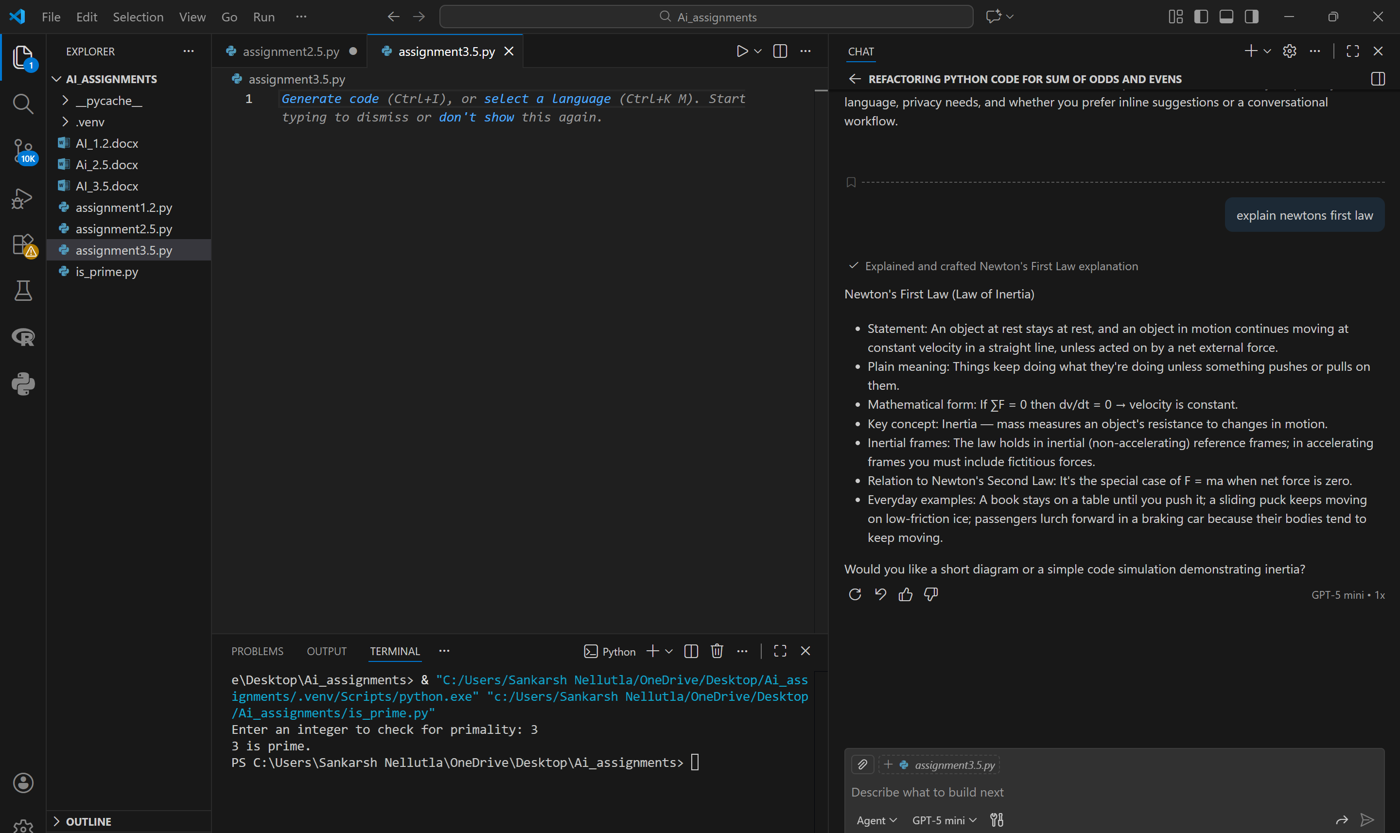

What is force?

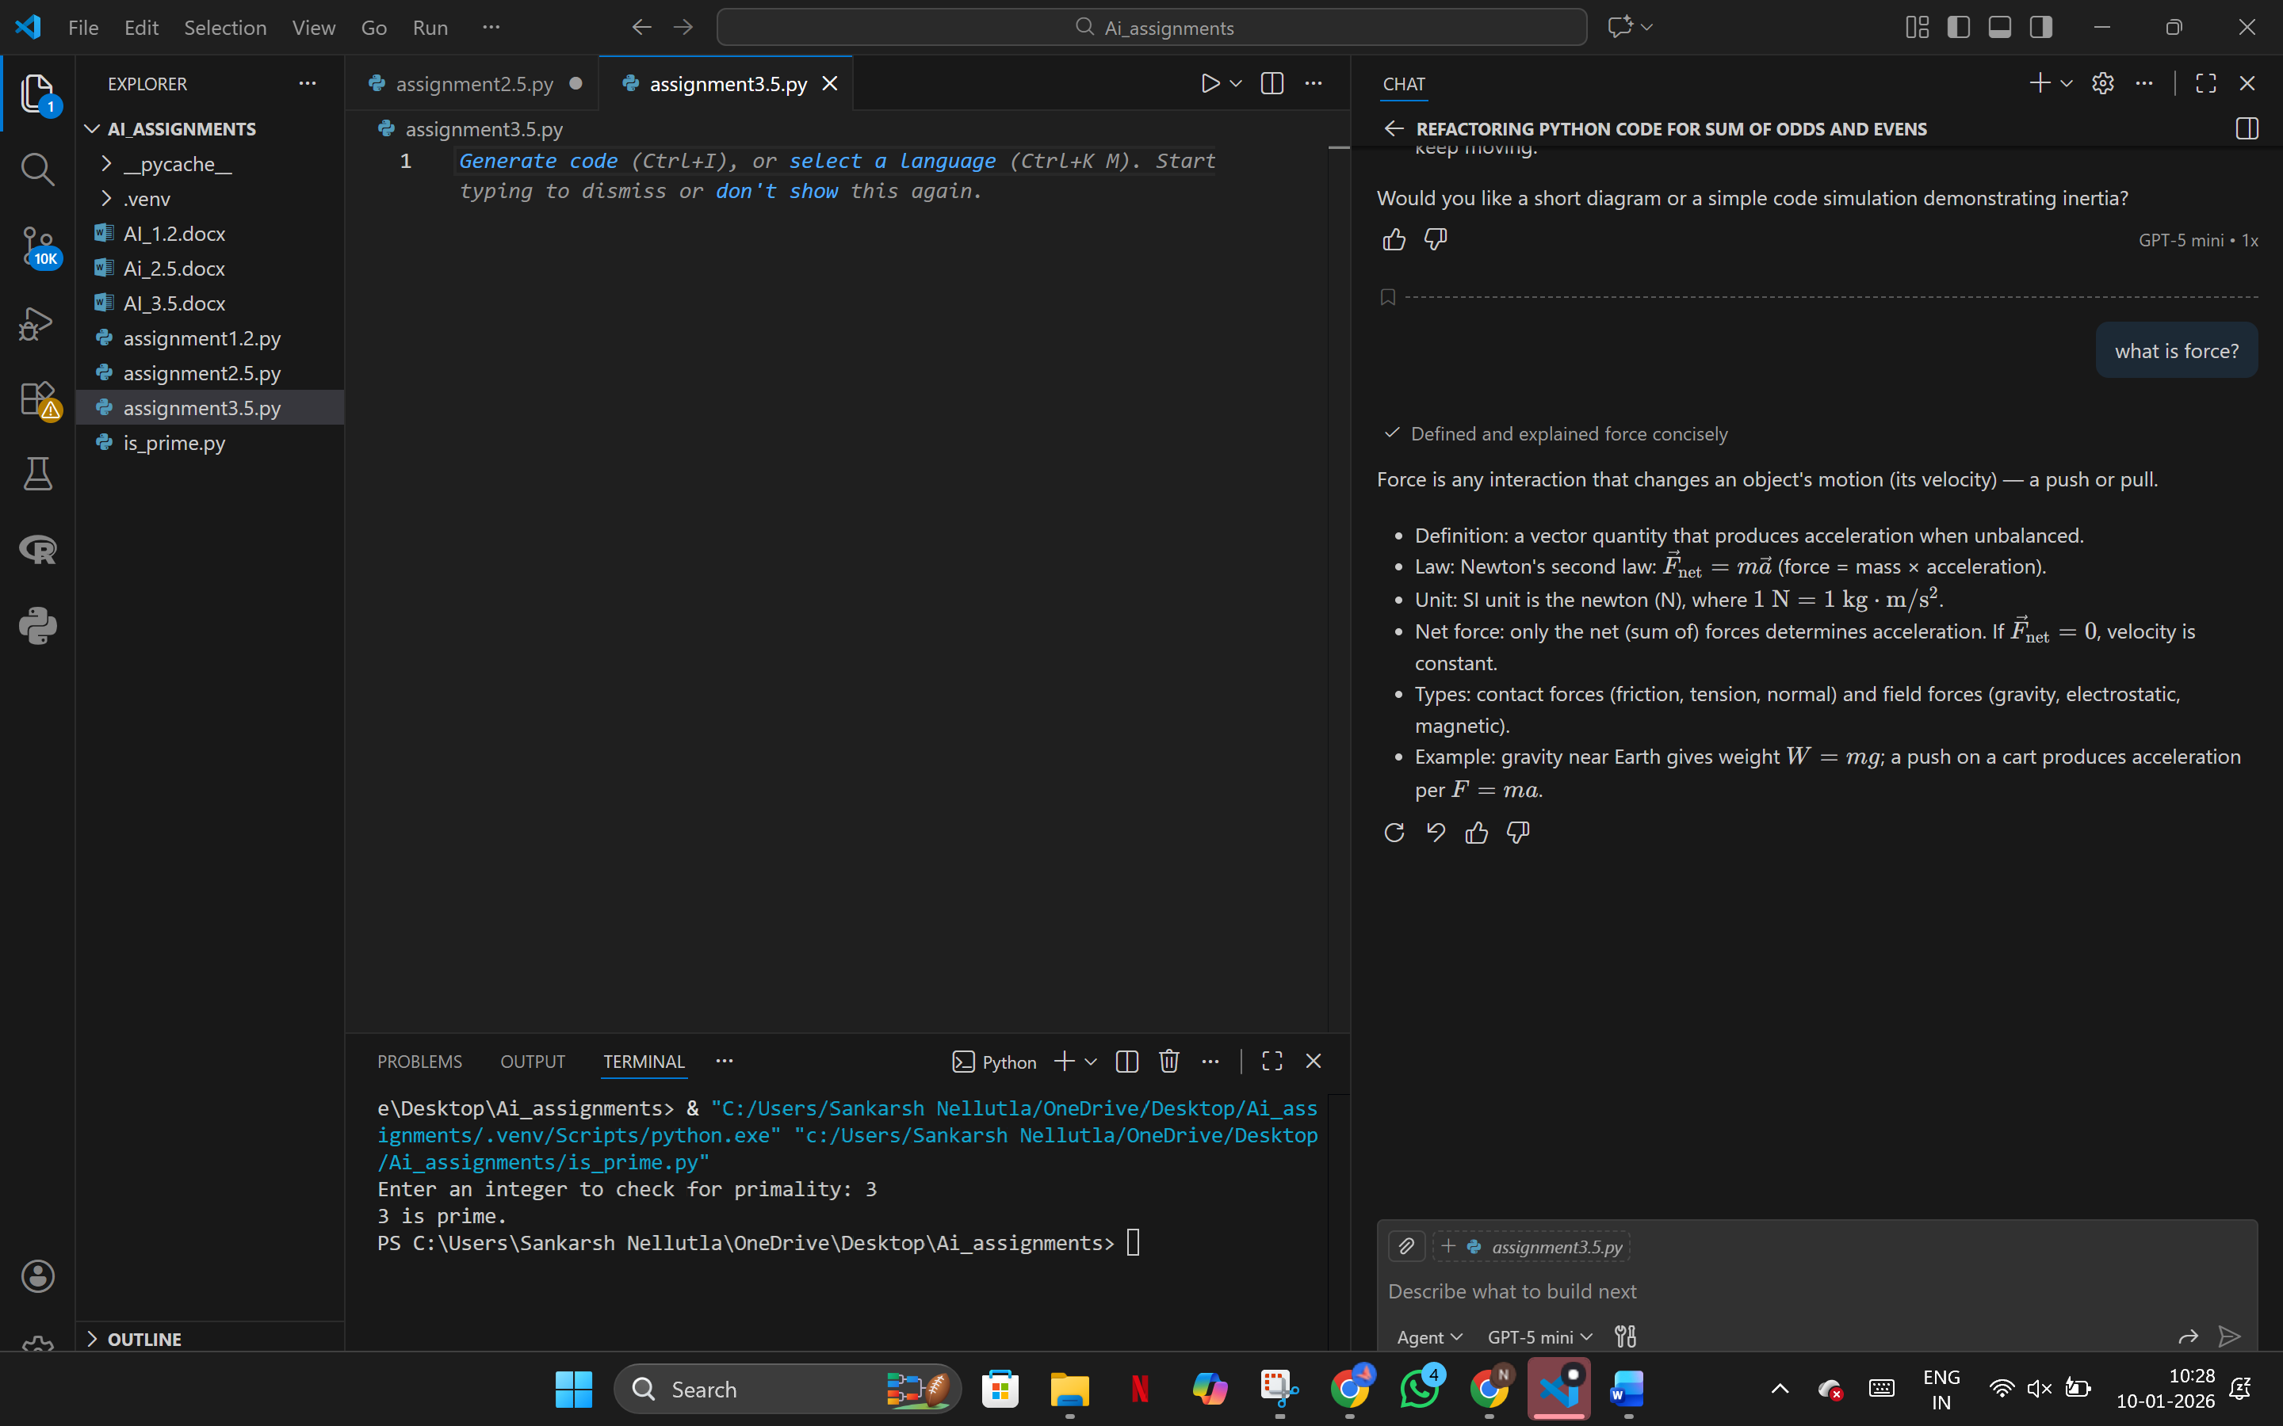

Define momentum

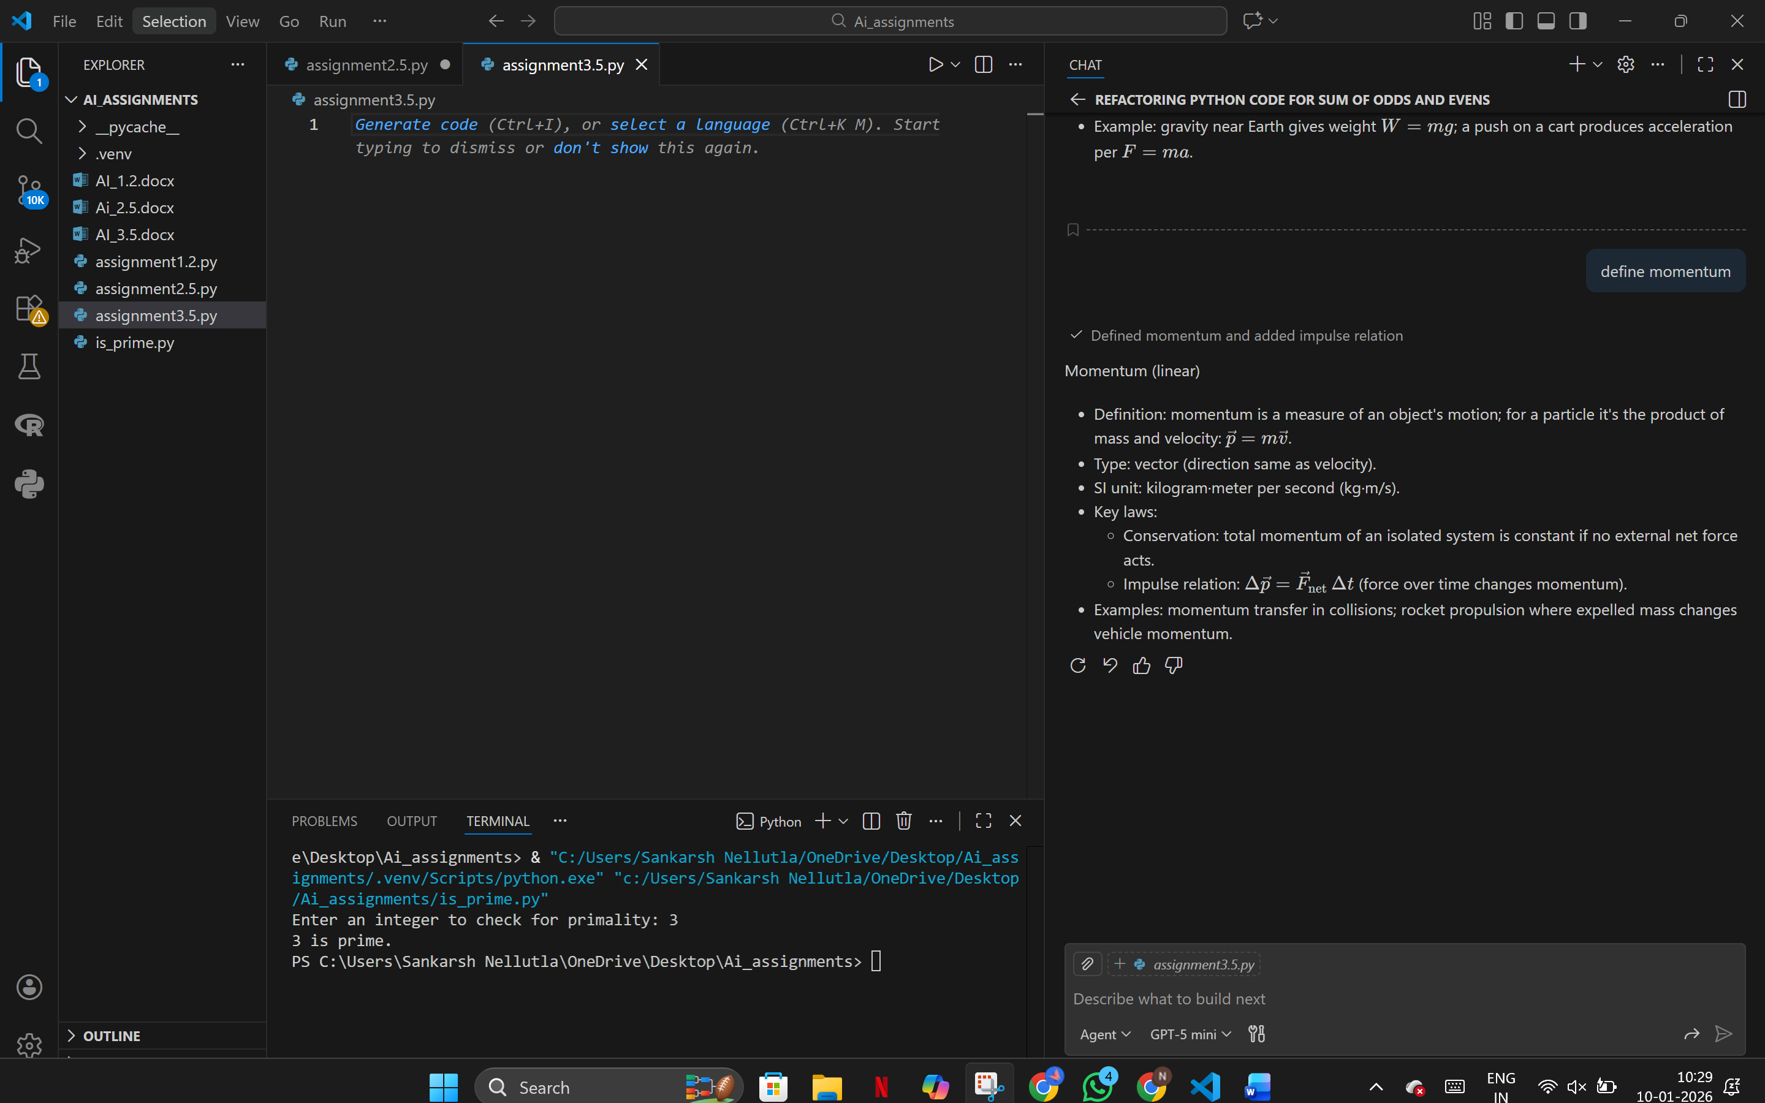

Why does an object fall downwards?

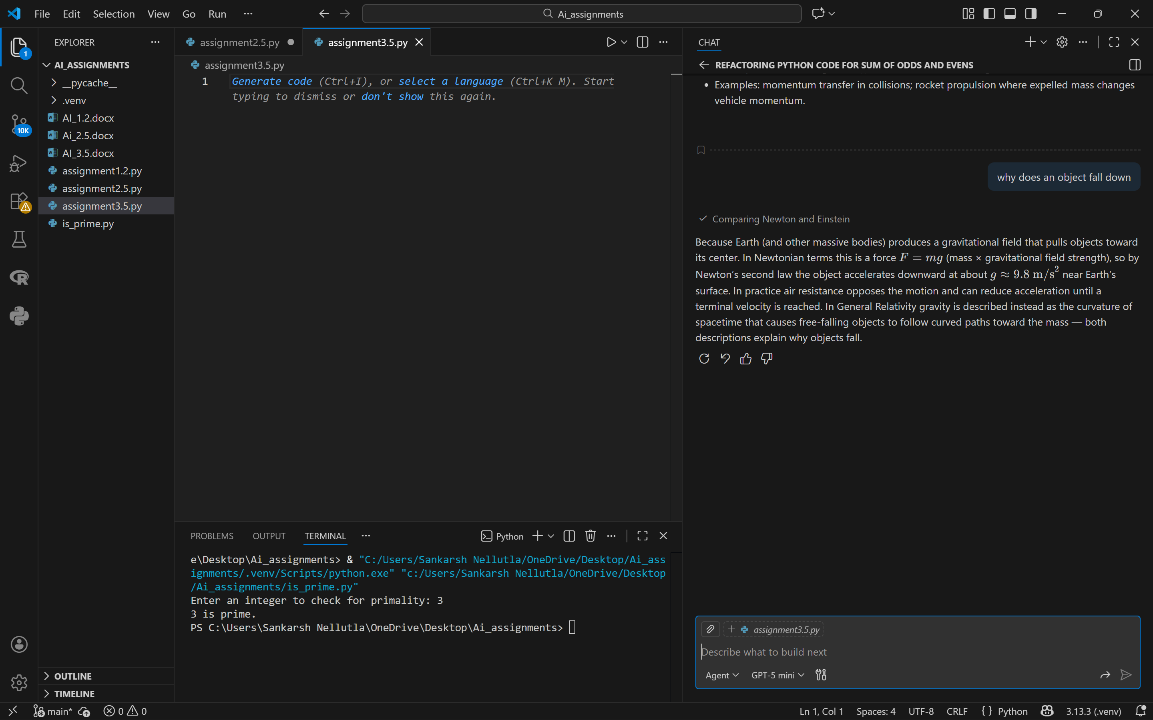

What is inertia

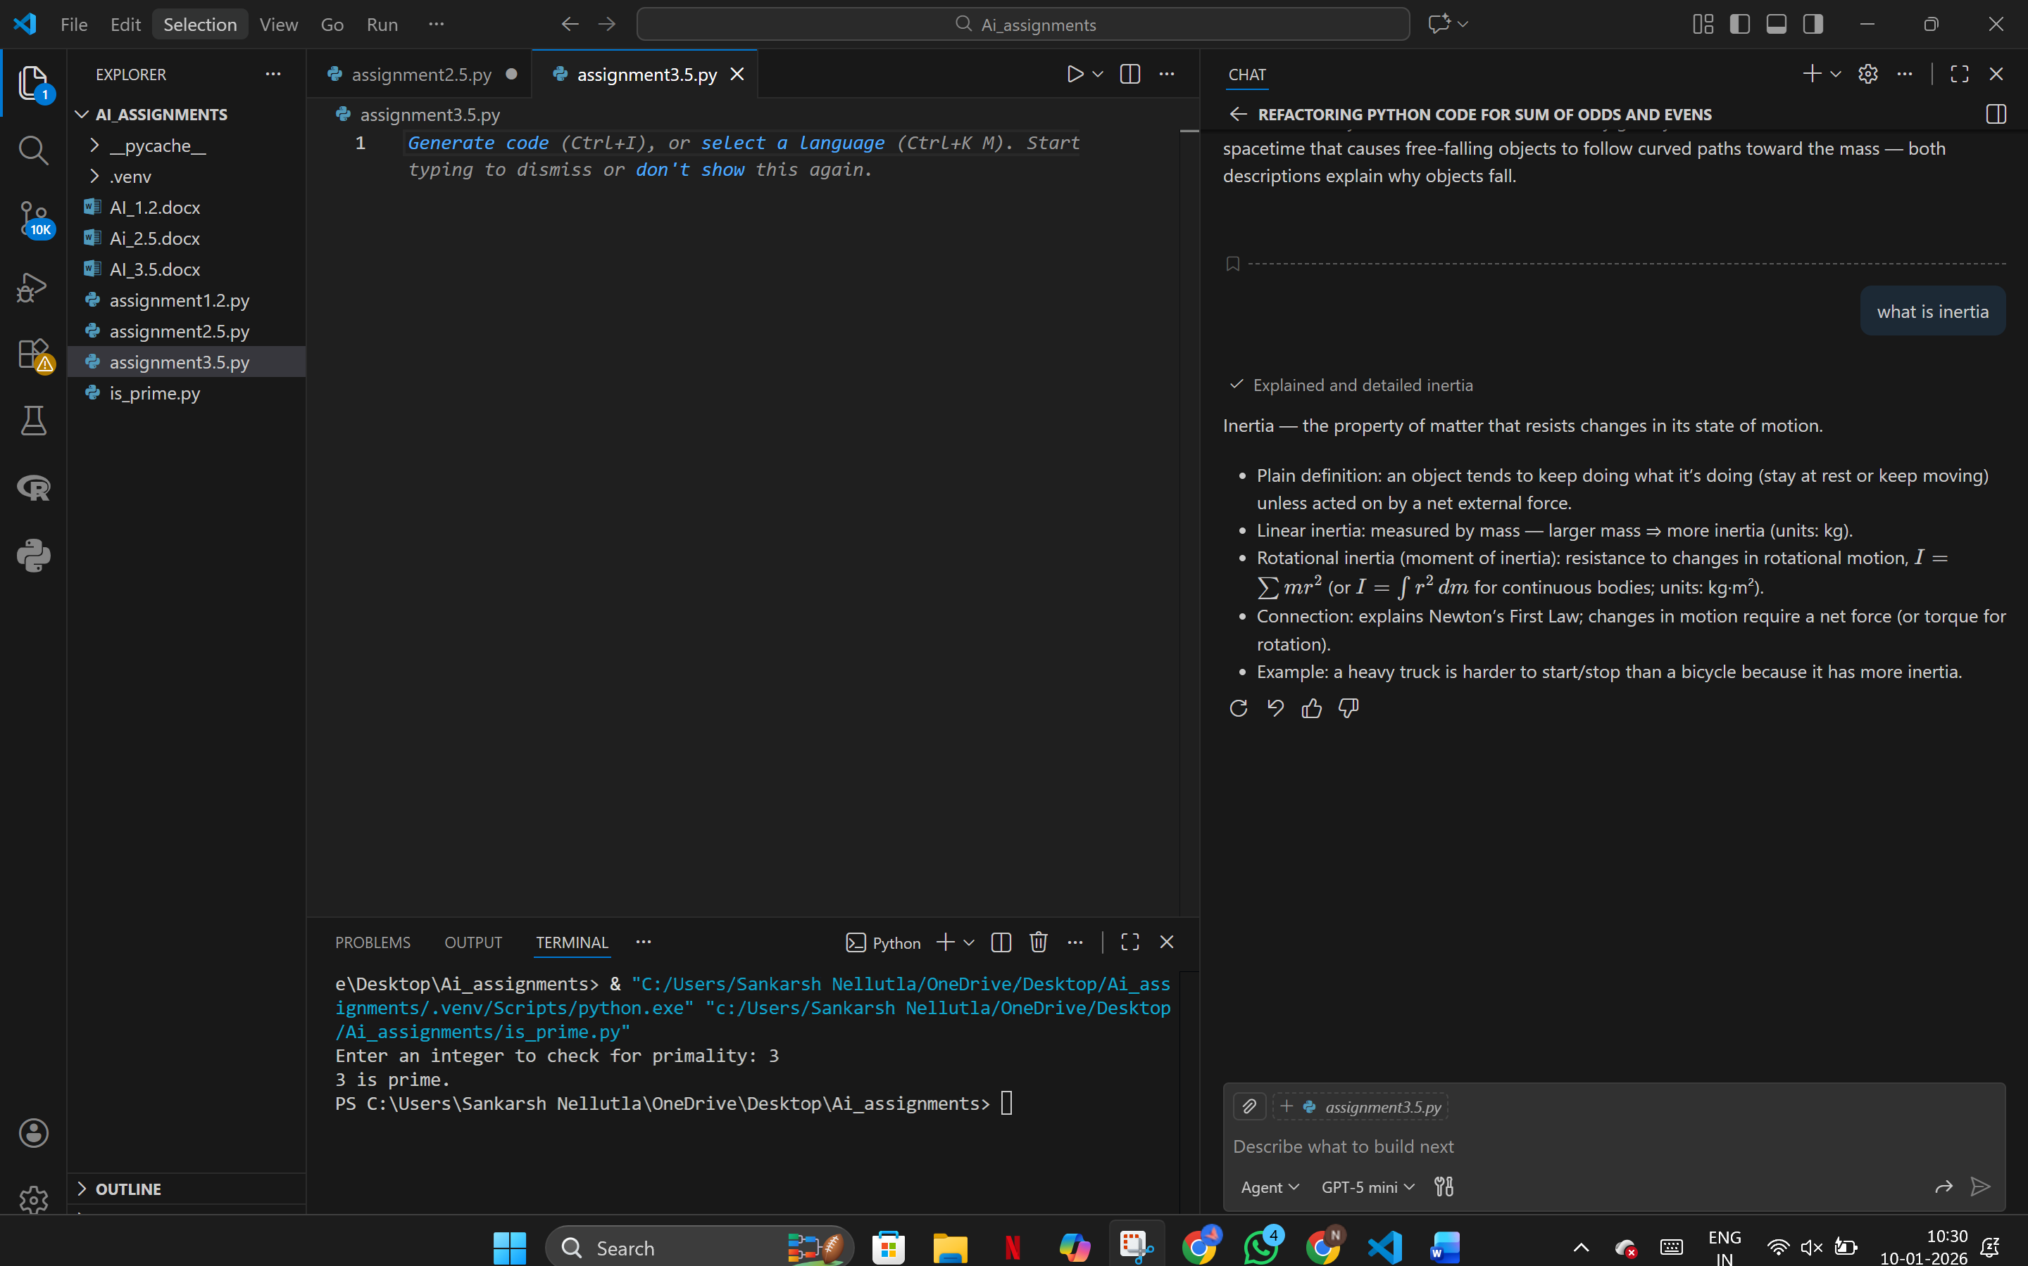

**Observation:**  
Responses were short, generic, and lacked examples or depth.

**2. Prompt Refinement**

Explain Newton’s First Law of Motion for school-level students.

Include:

1) Definition

2) Explanation

3) One real-life example

4) Mathematical representation (if any)

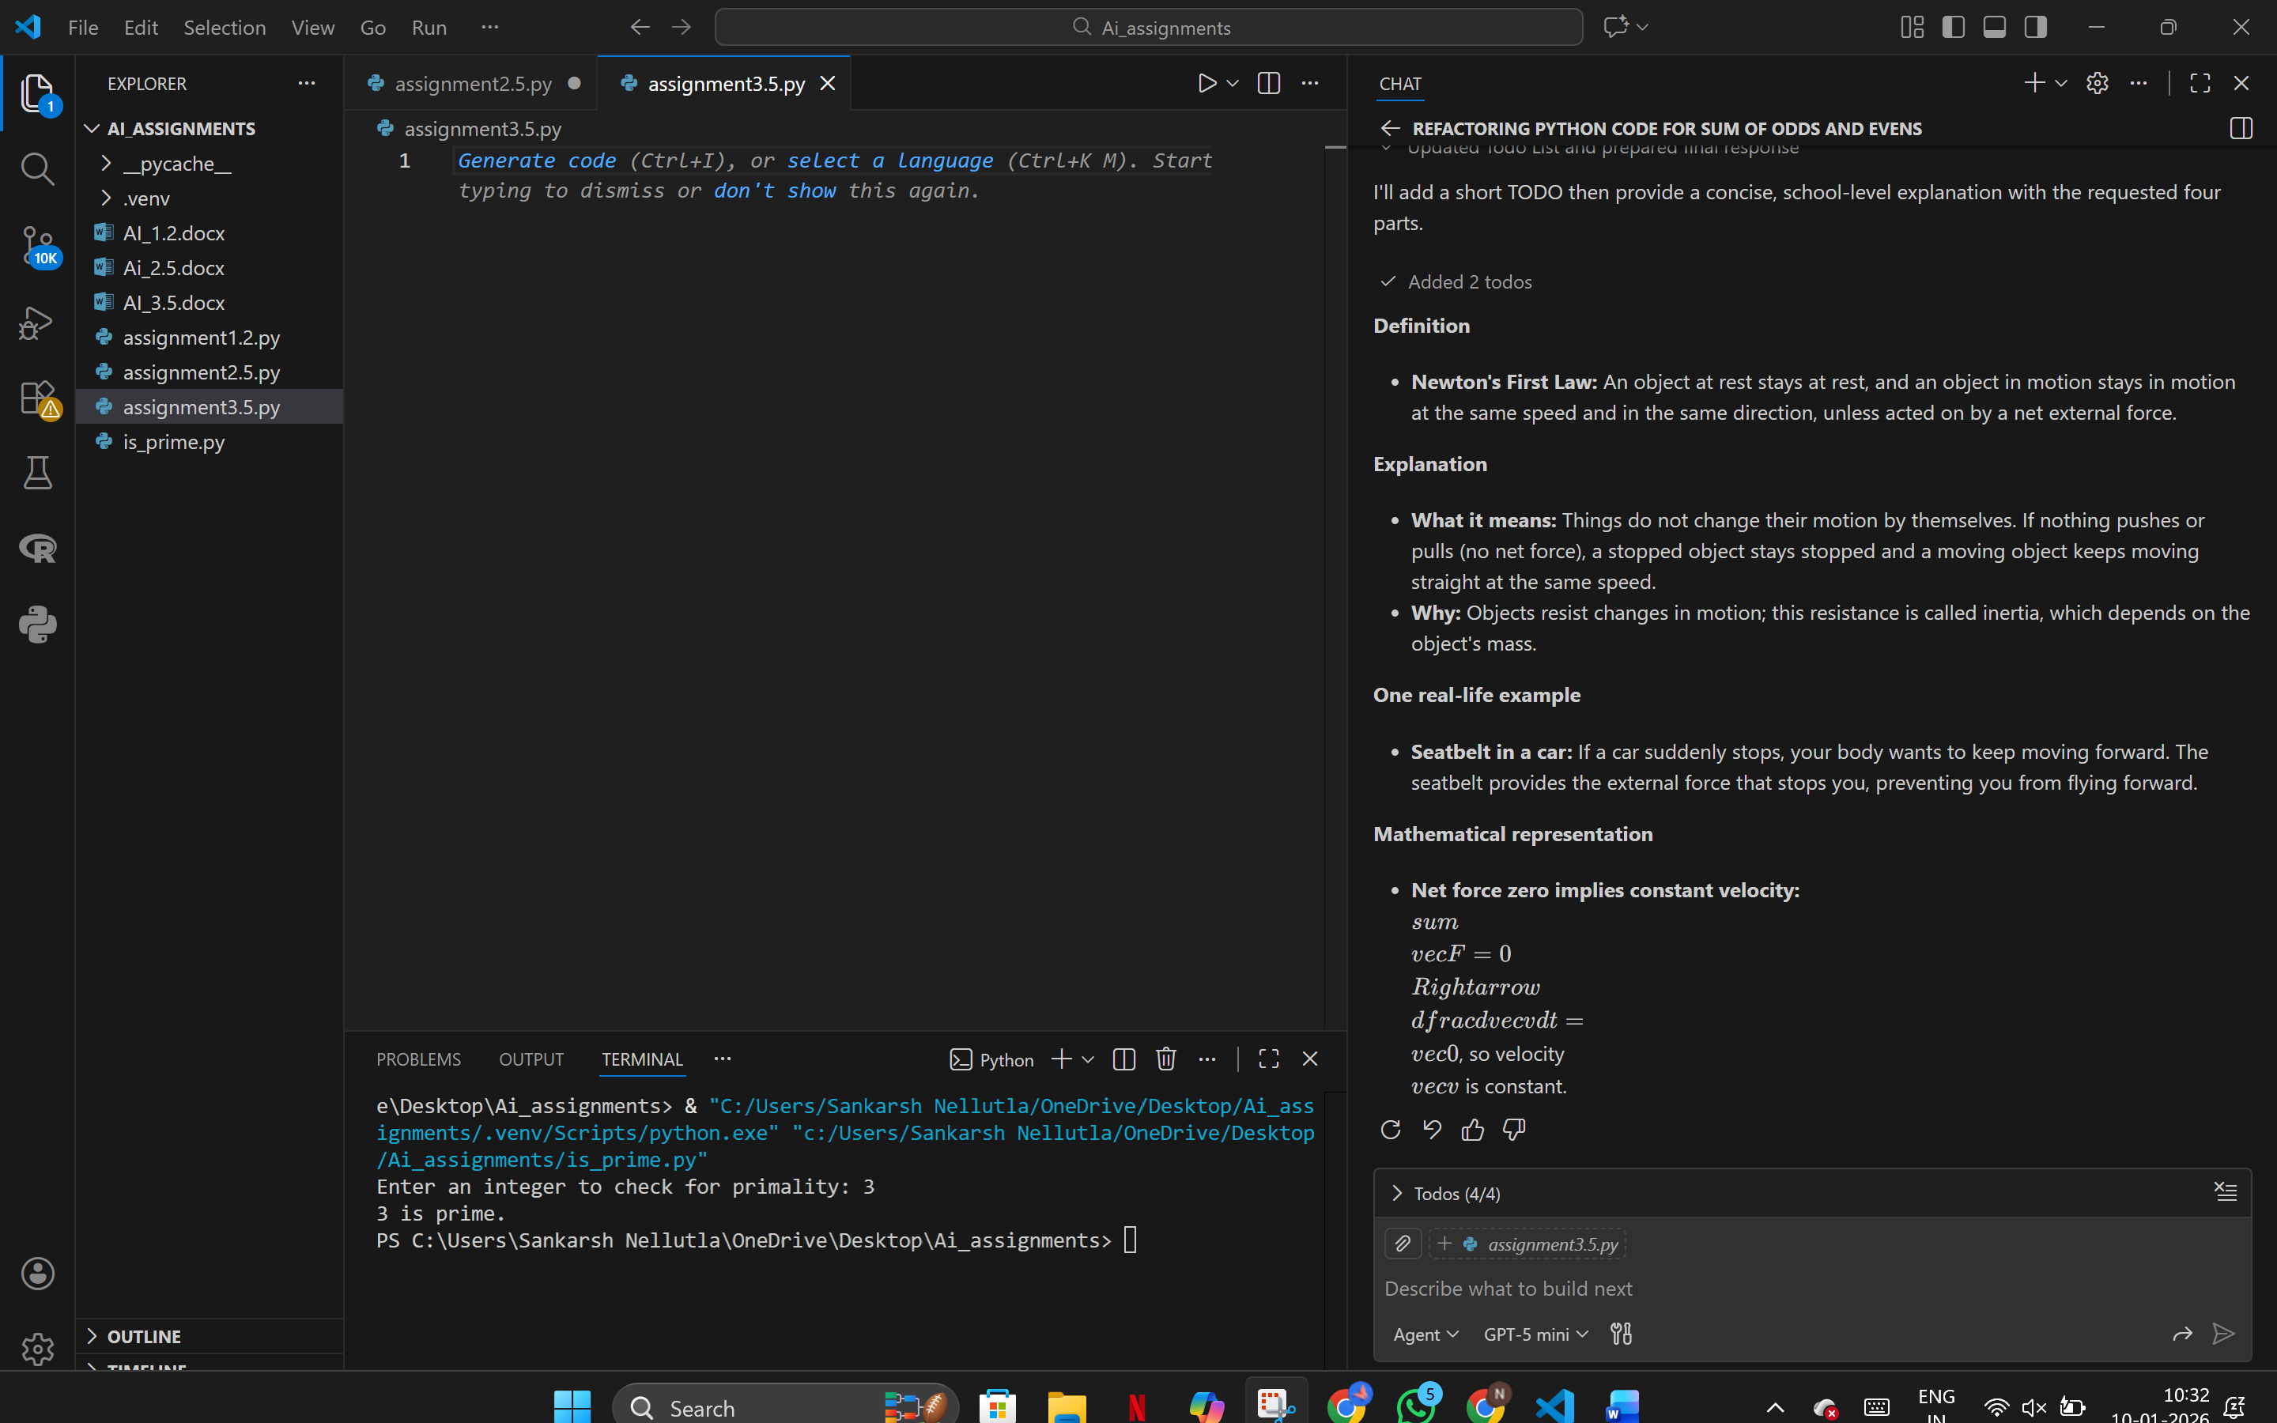

**Evaluation of Outputs**

| **Metric** | **Baseline (1–5)** | **Refined (1–5)** |
| --- | --- | --- |
| Completeness | 2 | 5 |
| Accuracy | 4 | 5 |
| Relevance | 3 | 5 |
| Clarity | 2 | 5 |

**Reflection**

Structured and contextual prompts significantly improved explanation depth, correctness, and learner understanding. GitHub Copilot generated more detailed and relevant content when instructions were explicit.

**Task 2: Programming Fundamentals (Python)**

What is a loop in Python?

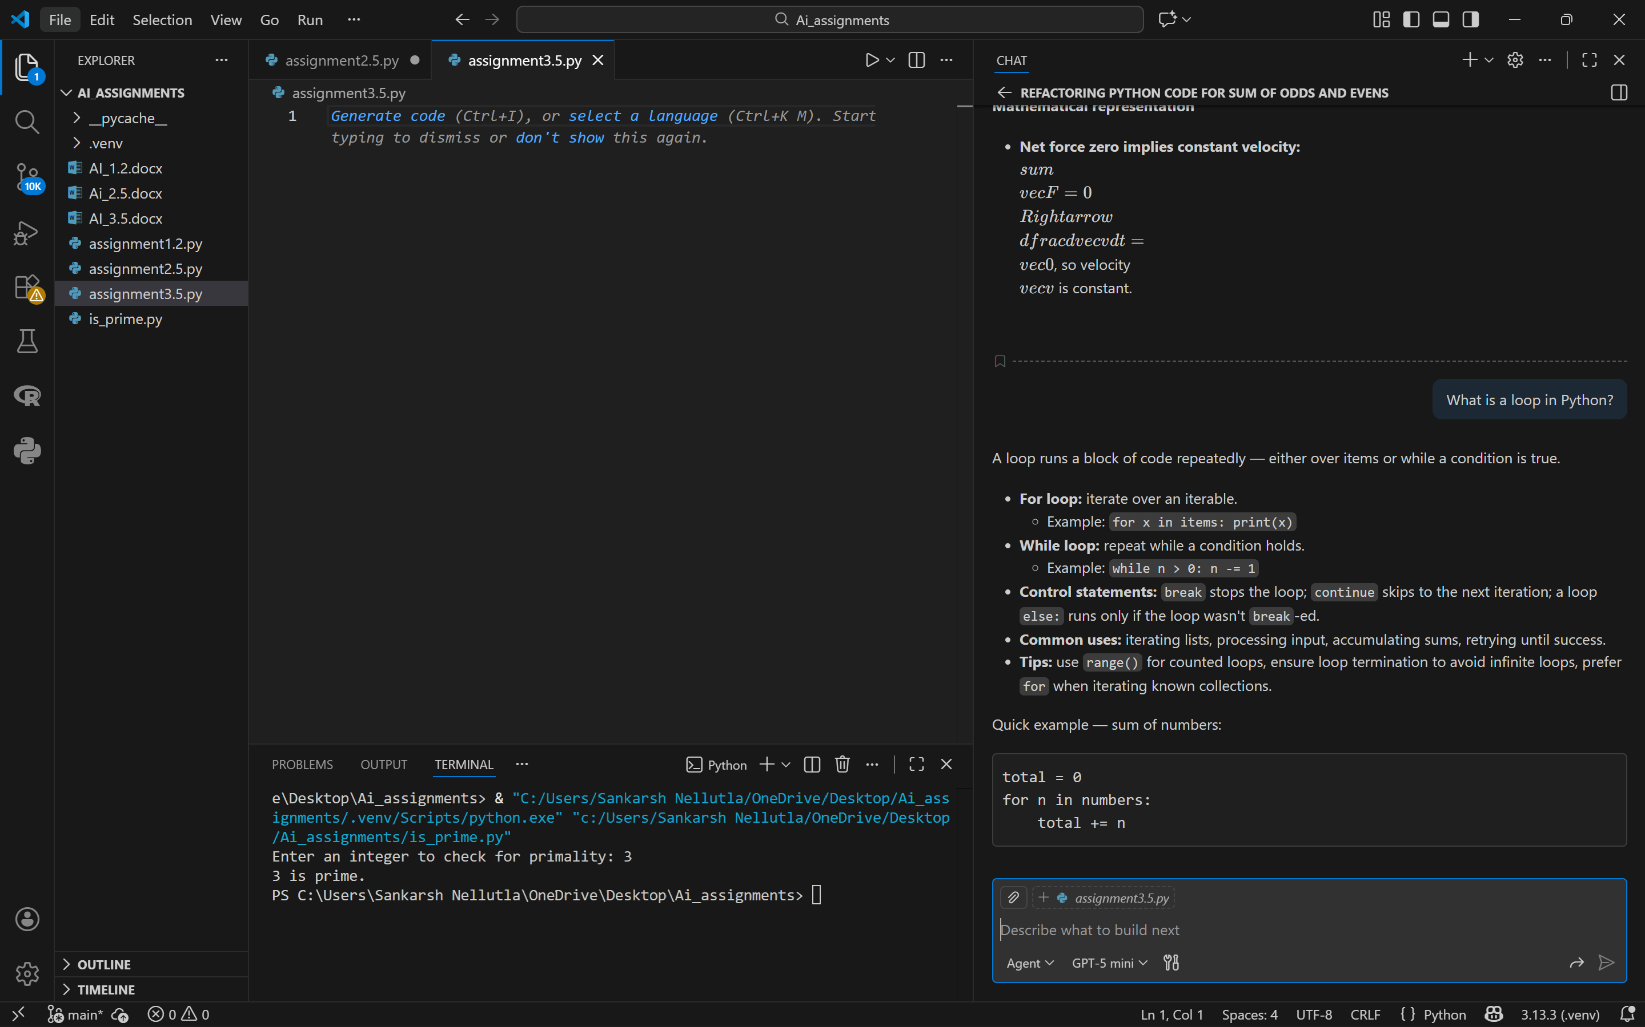

Explain if-else

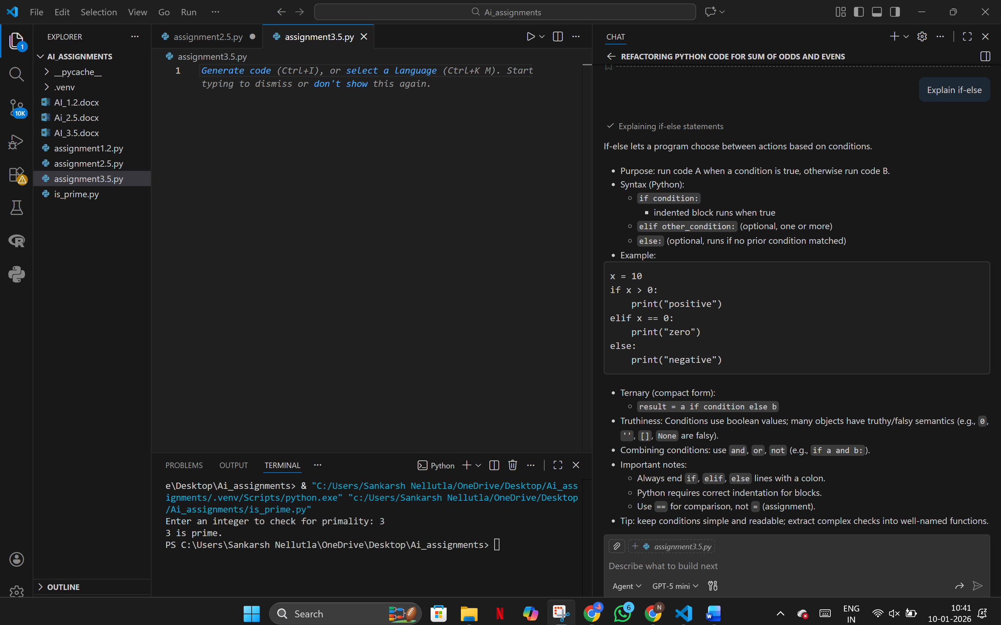

How does a function work?

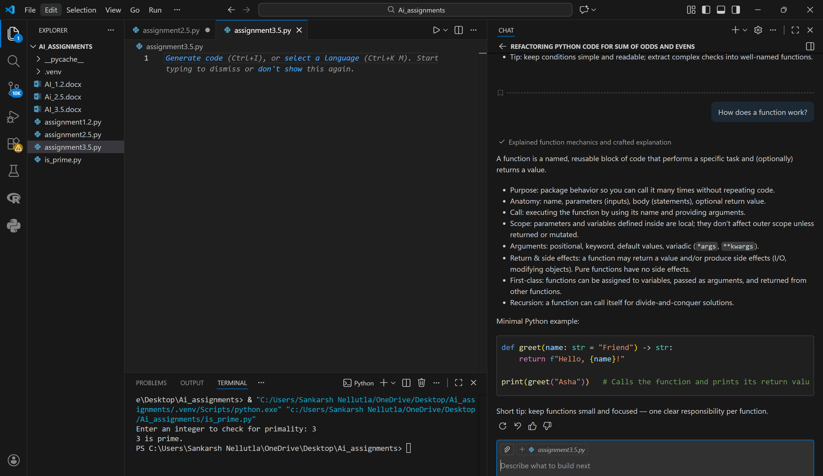

What is the difference between list and tuple?

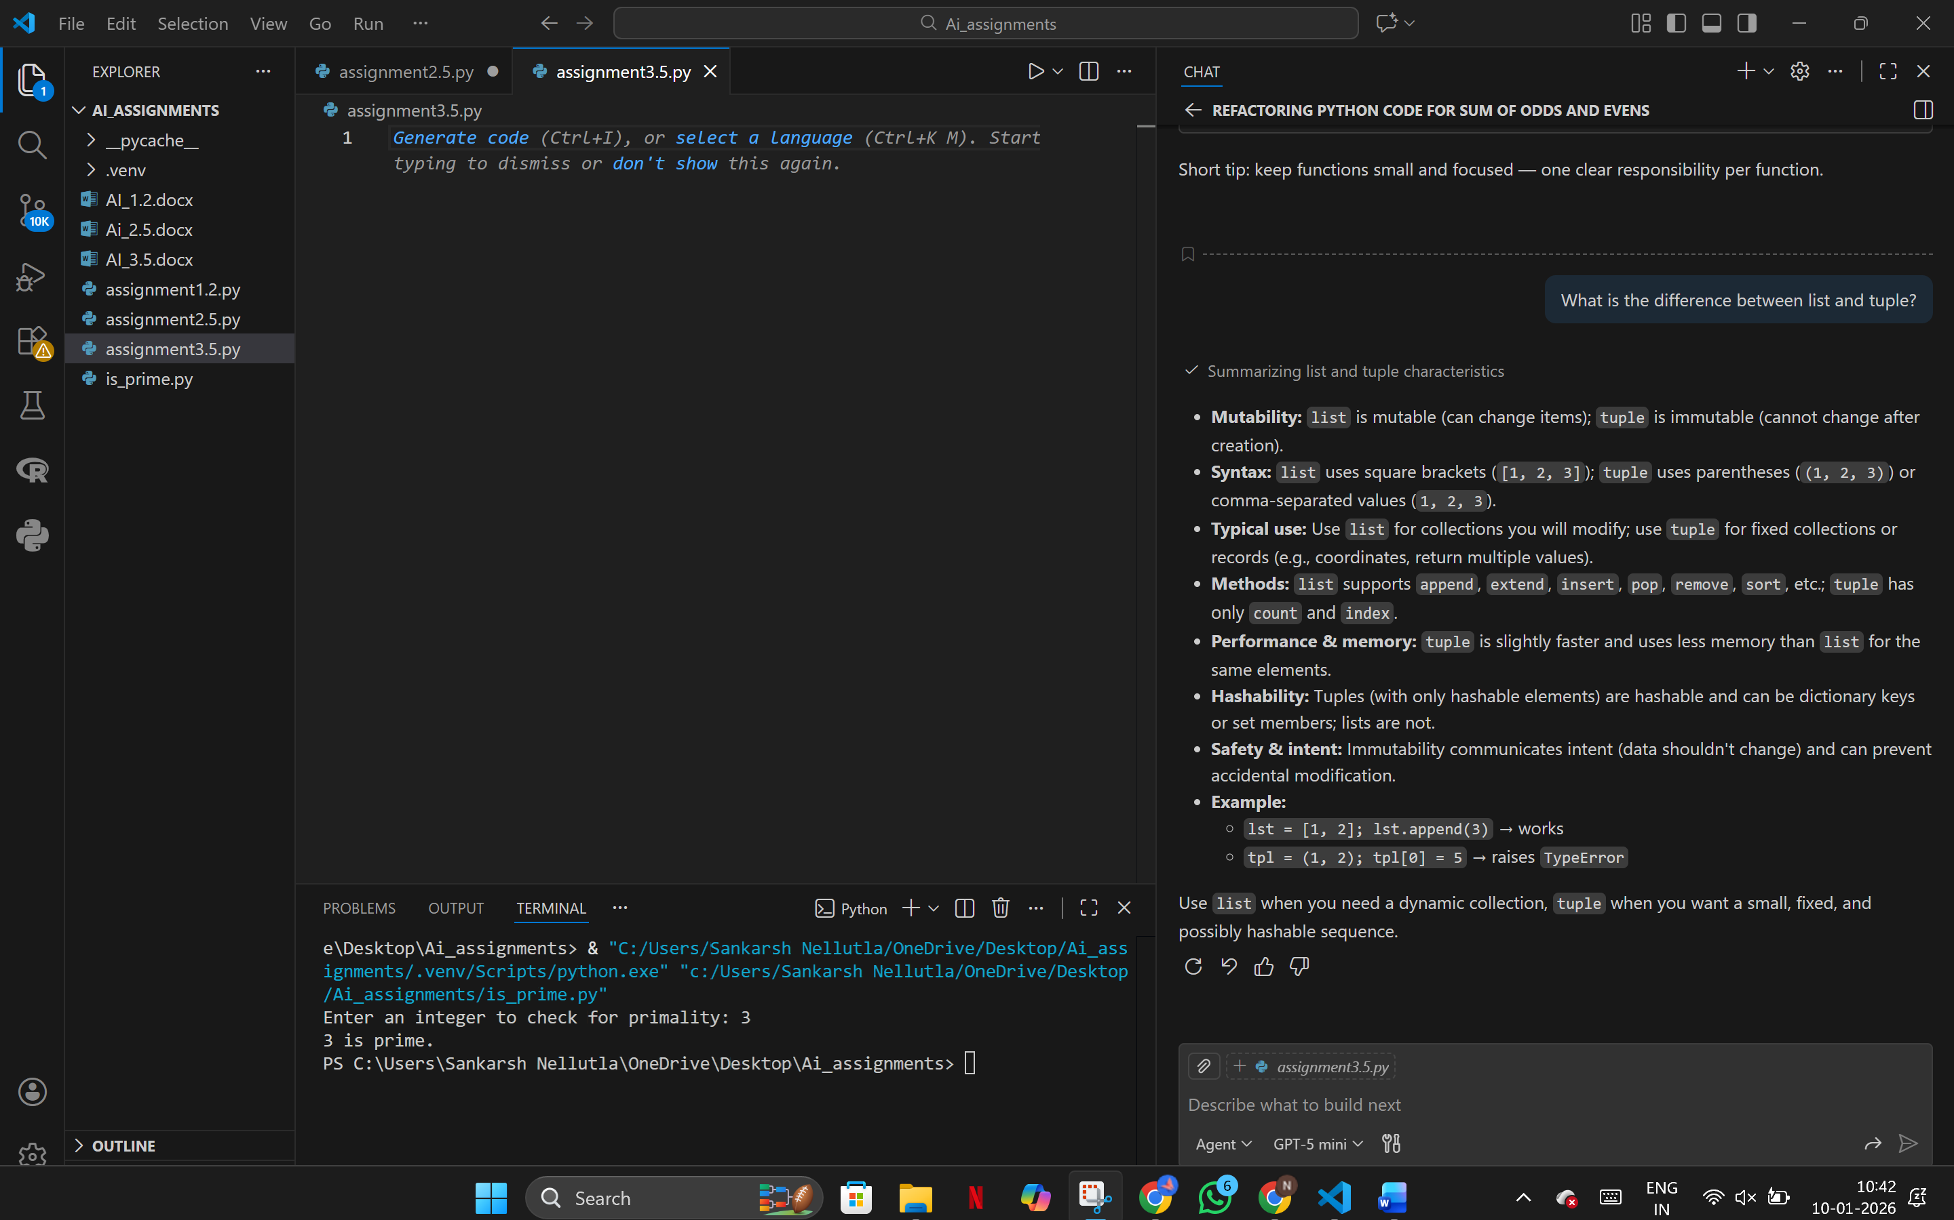

What is recursion?

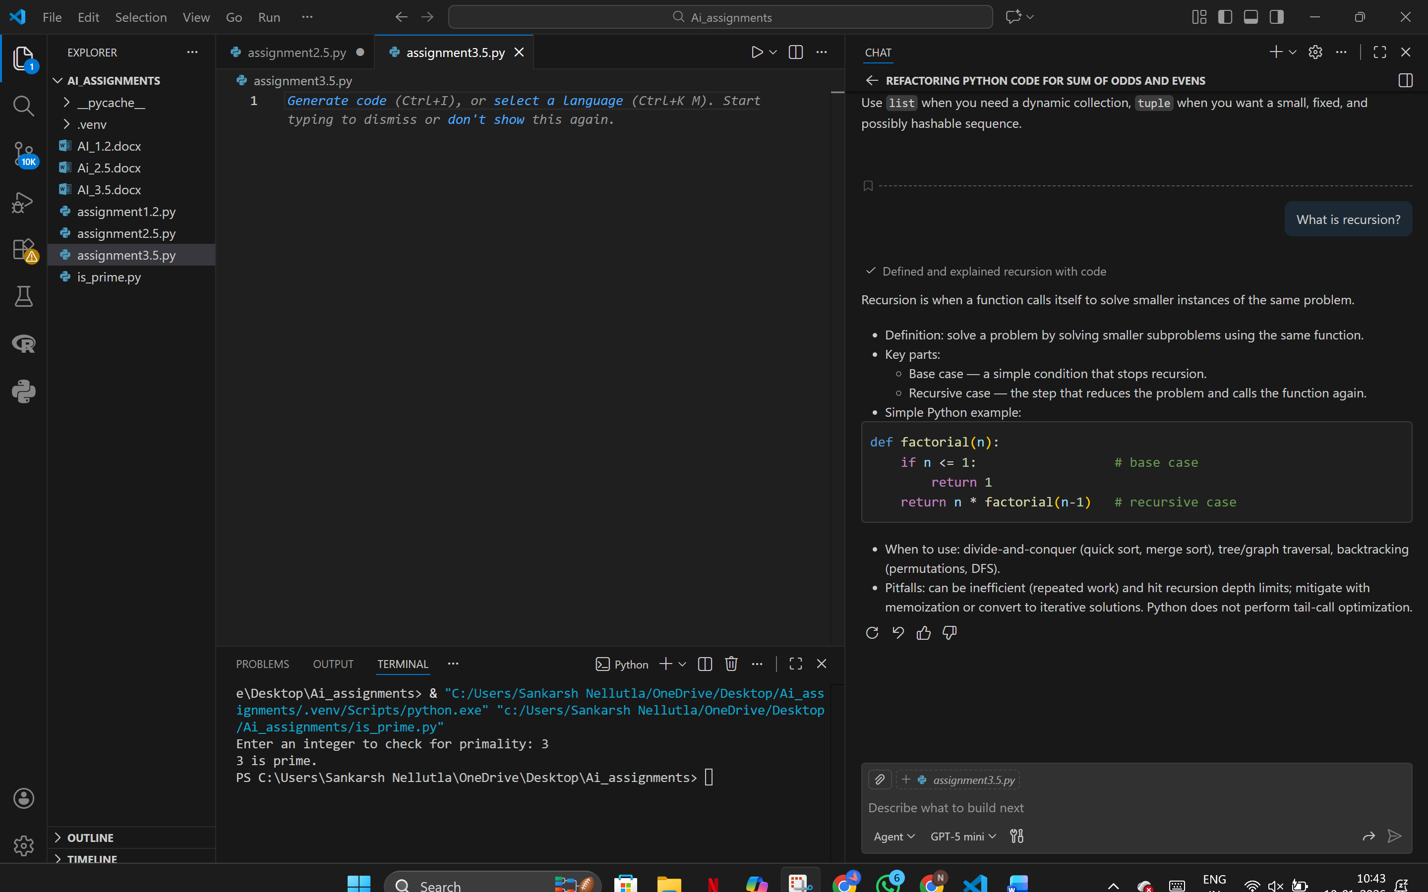

Prompt Refinement

# Define a Python loop for beginners

# Explain its purpose

# Show syntax

# Provide one for-loop example

# Mention one real-world use case

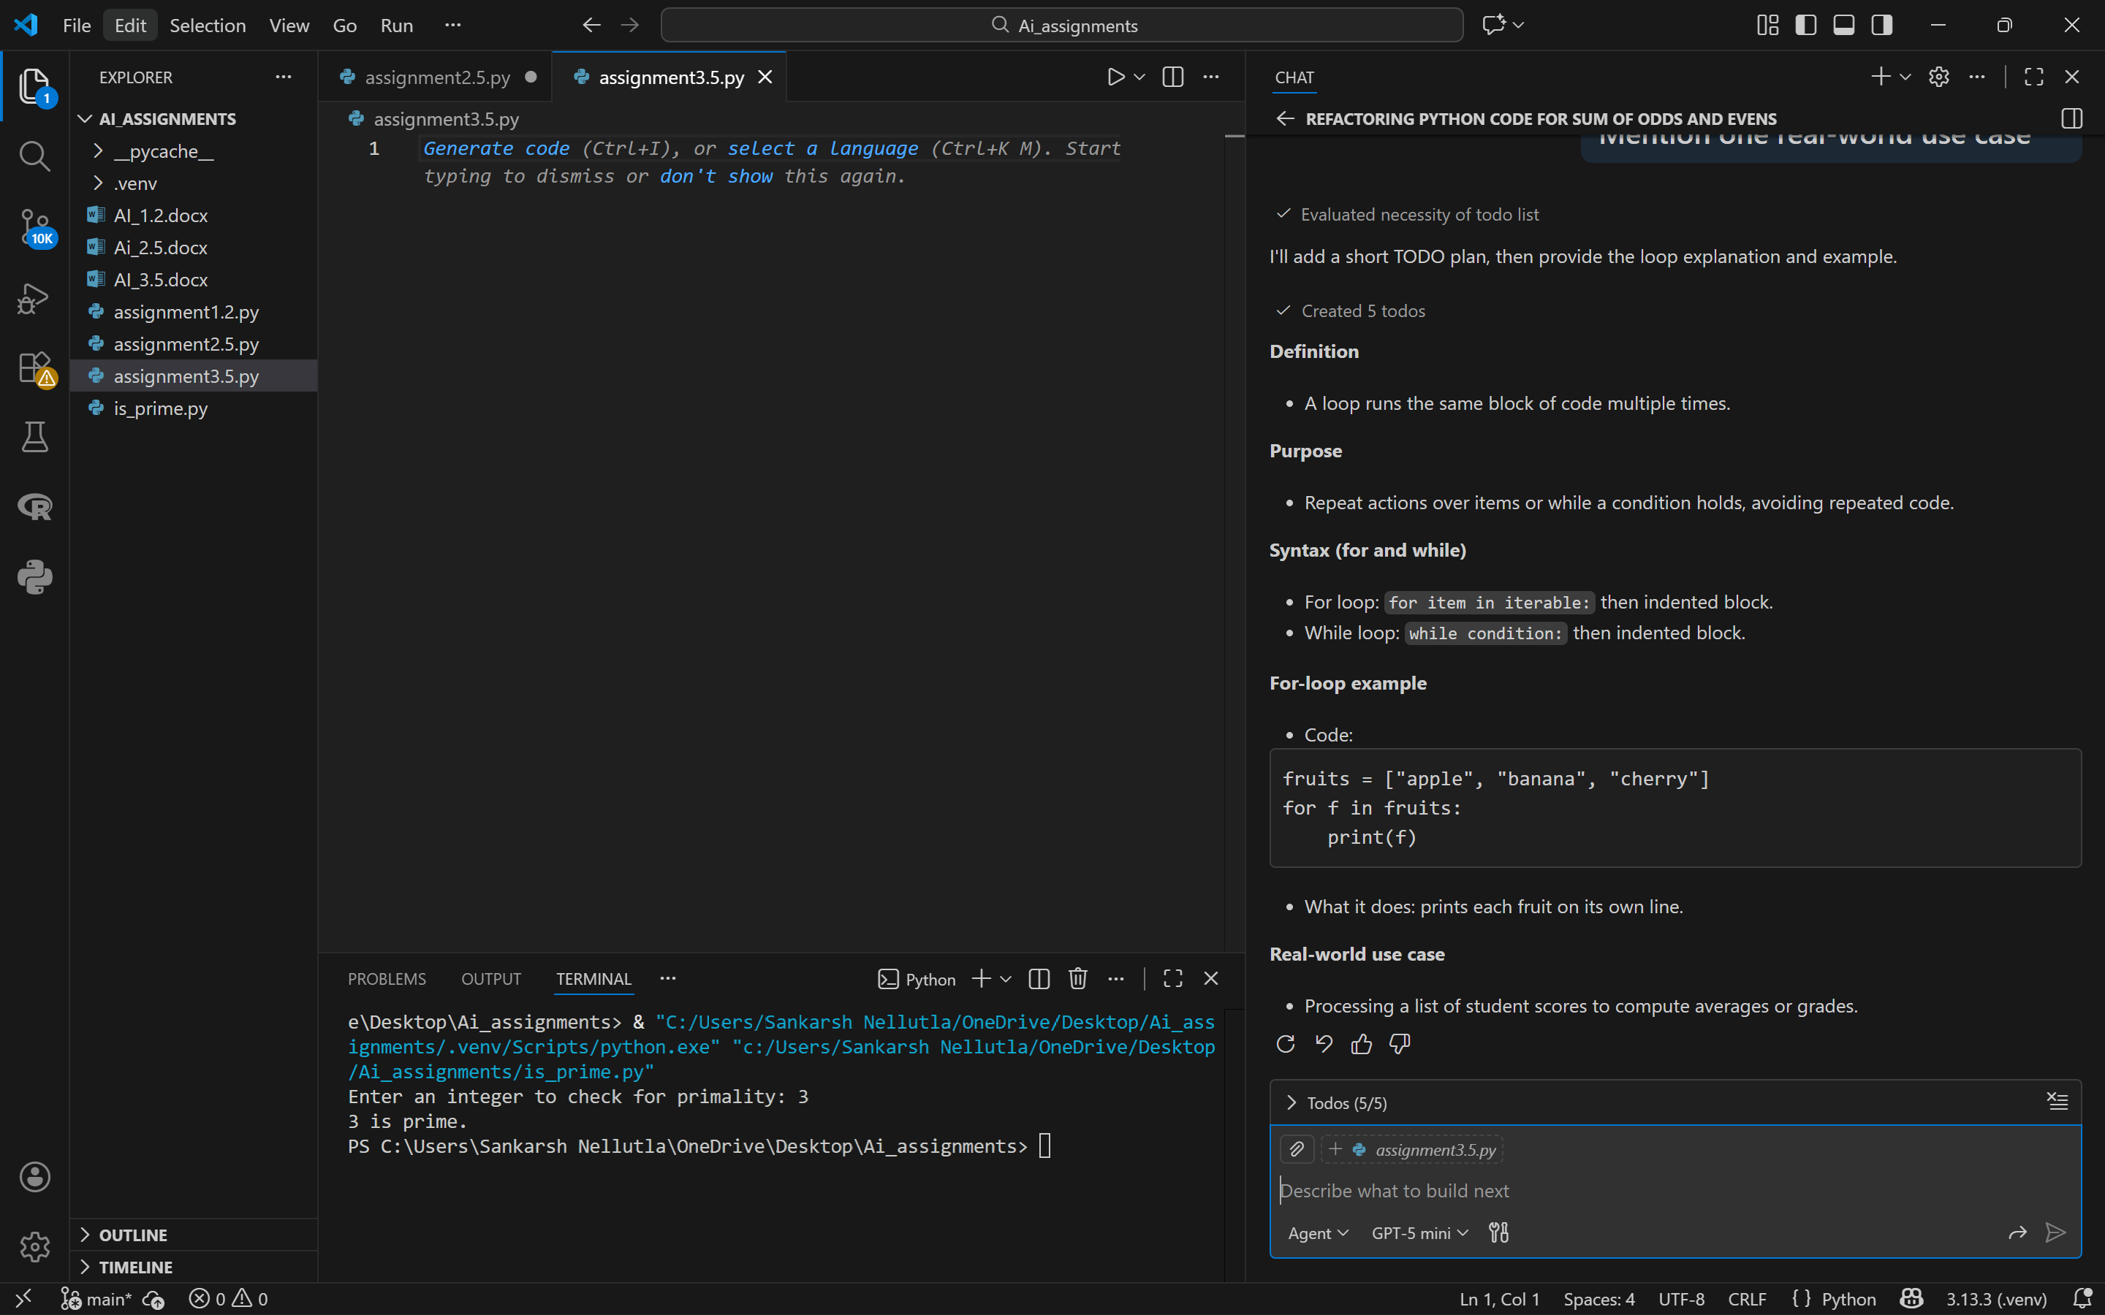

**Evaluation Summary**

| **Metric** | **Baseline** | **Refined** |
| --- | --- | --- |
| **Completeness** | **2** | **5** |
| **Accuracy** | **4** | **5** |
| **Relevance** | **3** | **5** |
| **Clarity** | **3** | **5** |

**Reflection**

Breaking prompts into subtasks improved code correctness and explanation quality. GitHub Copilot generated cleaner examples with better structure.

**Task 3: Data Science and Machine Learning Concepts**

**What is machine learning?**

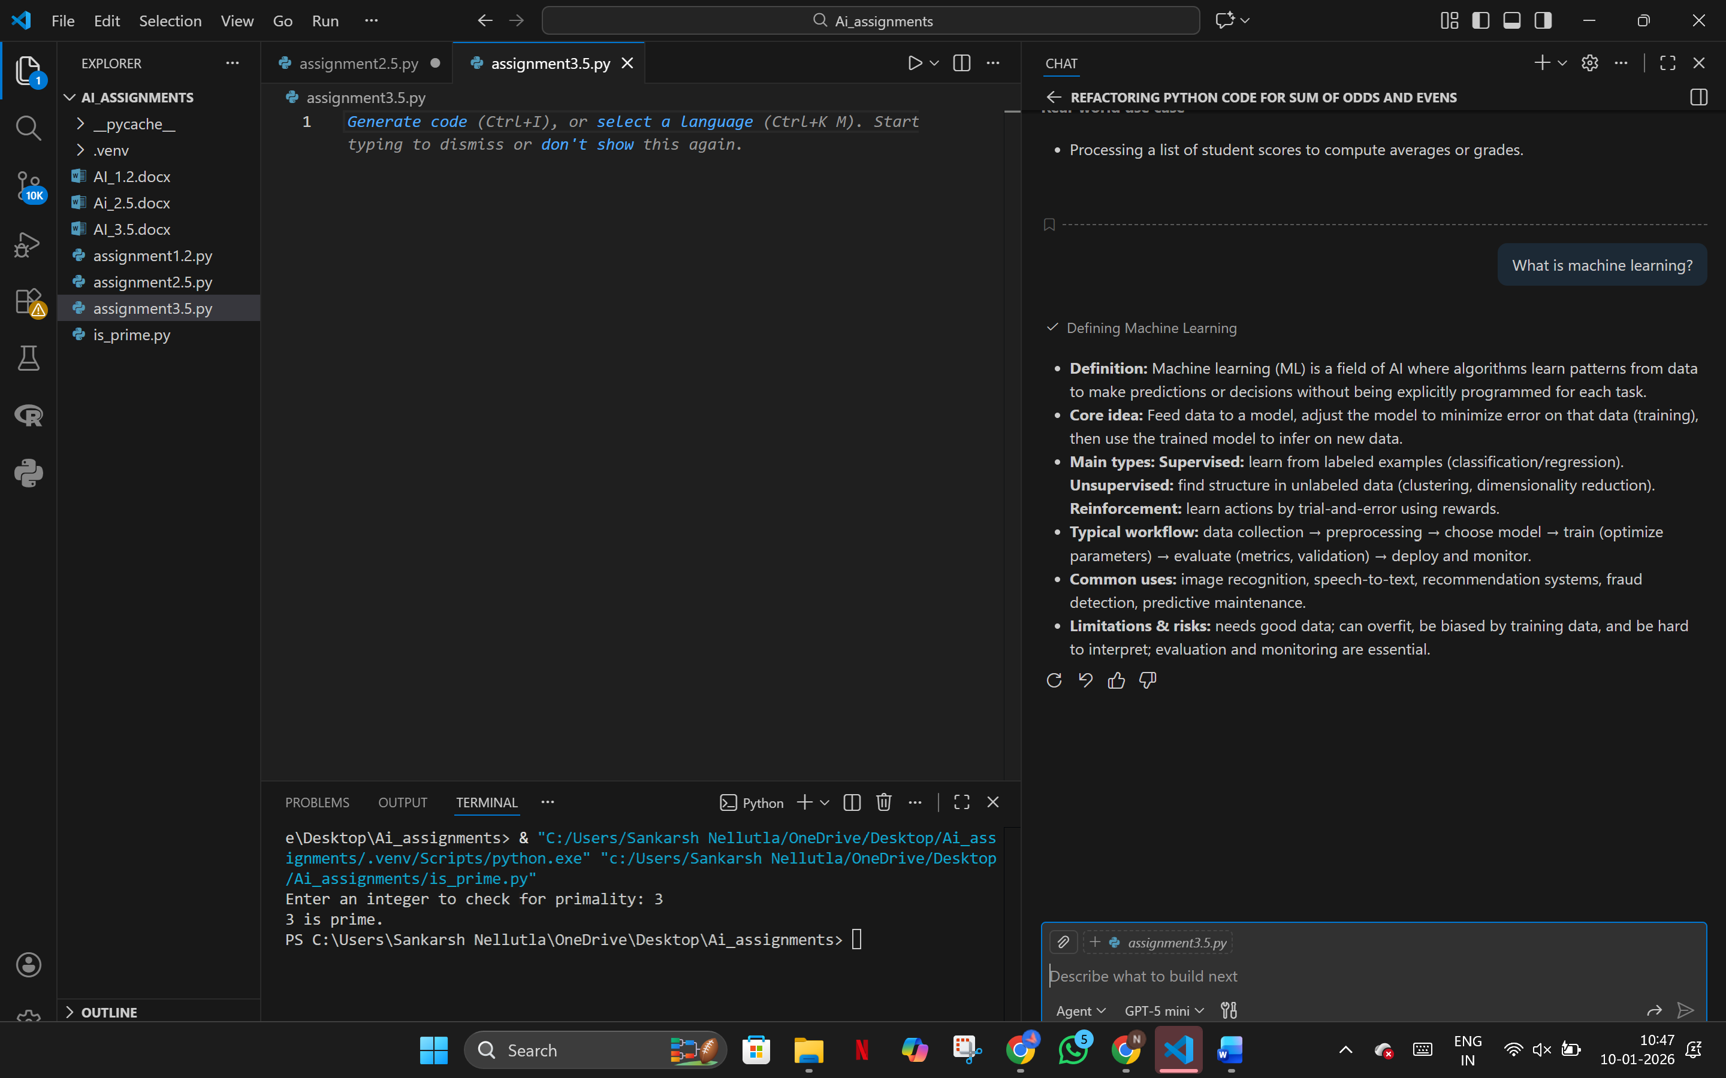

**Explain supervised learning**

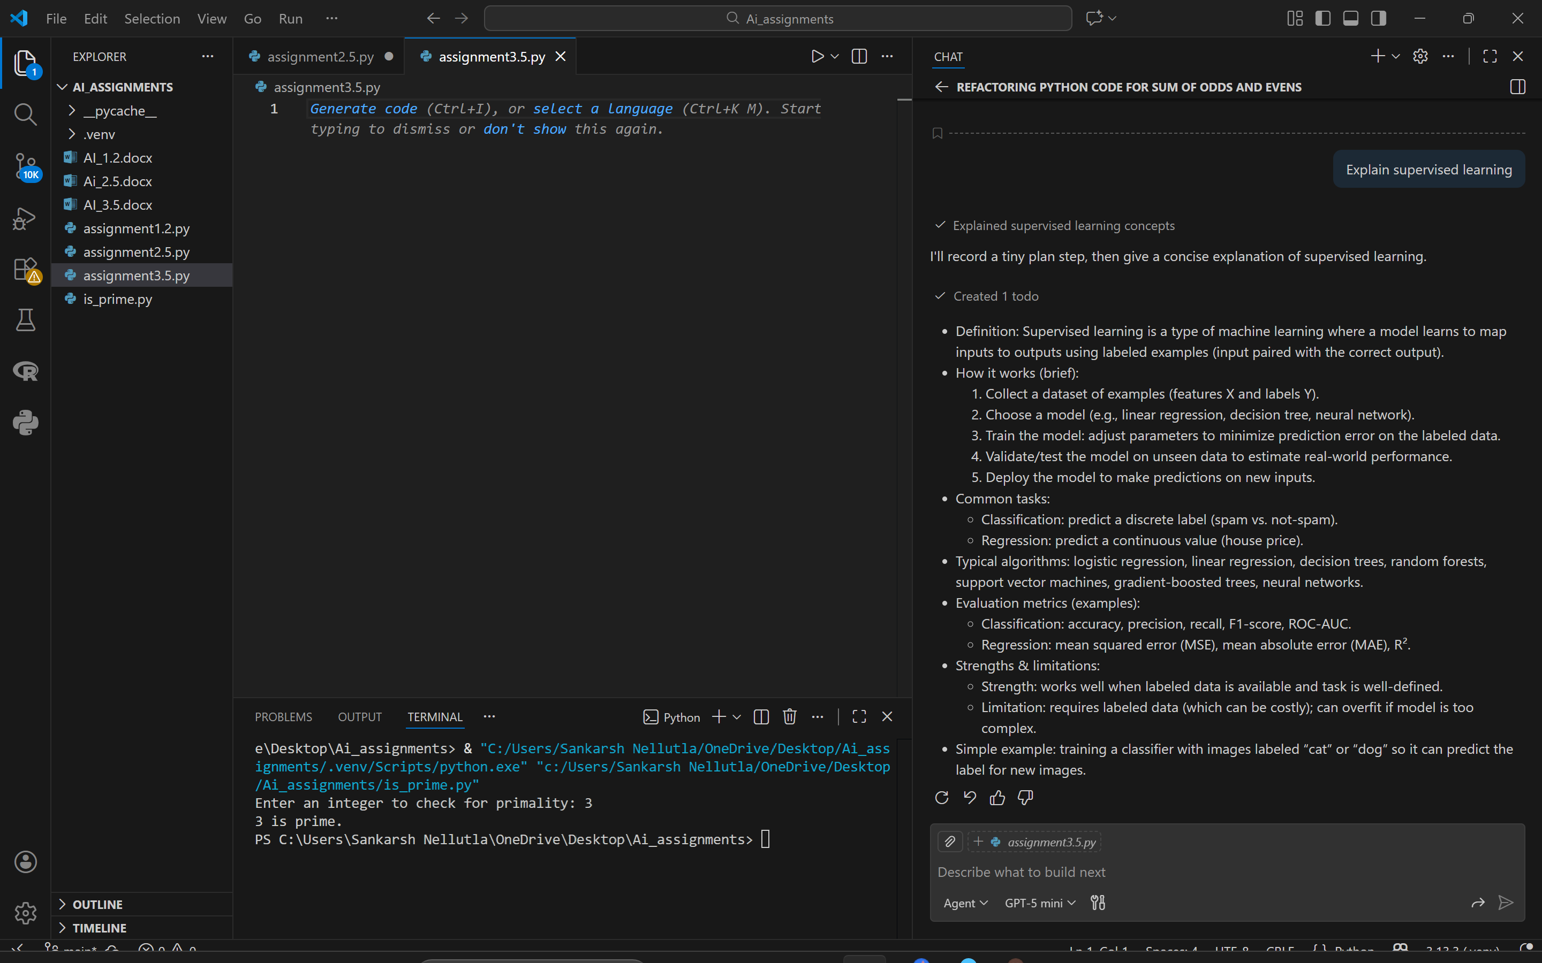

**What is regression?**

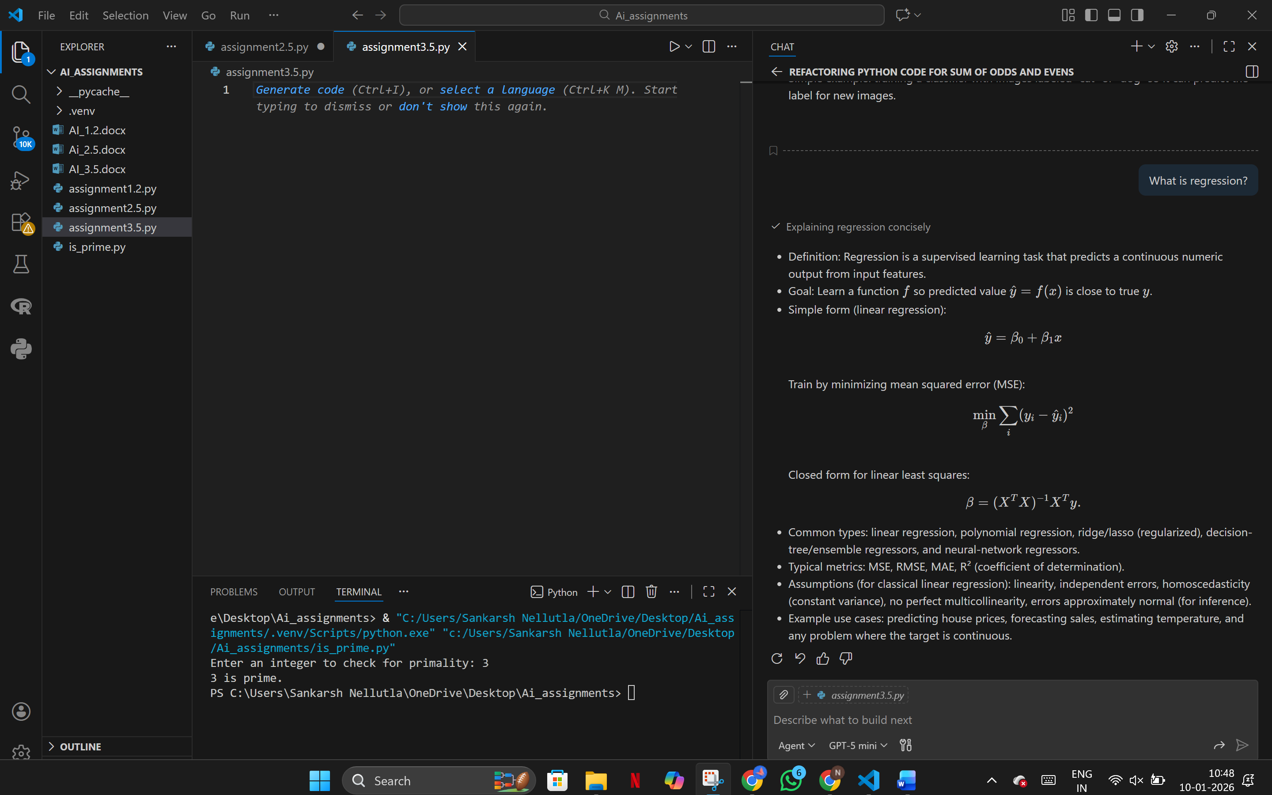

**Define overfitting**

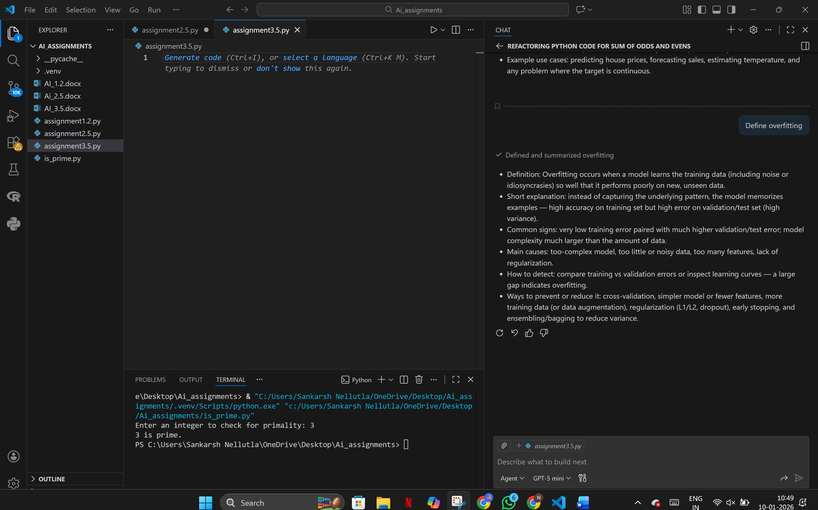

**What is clustering?**

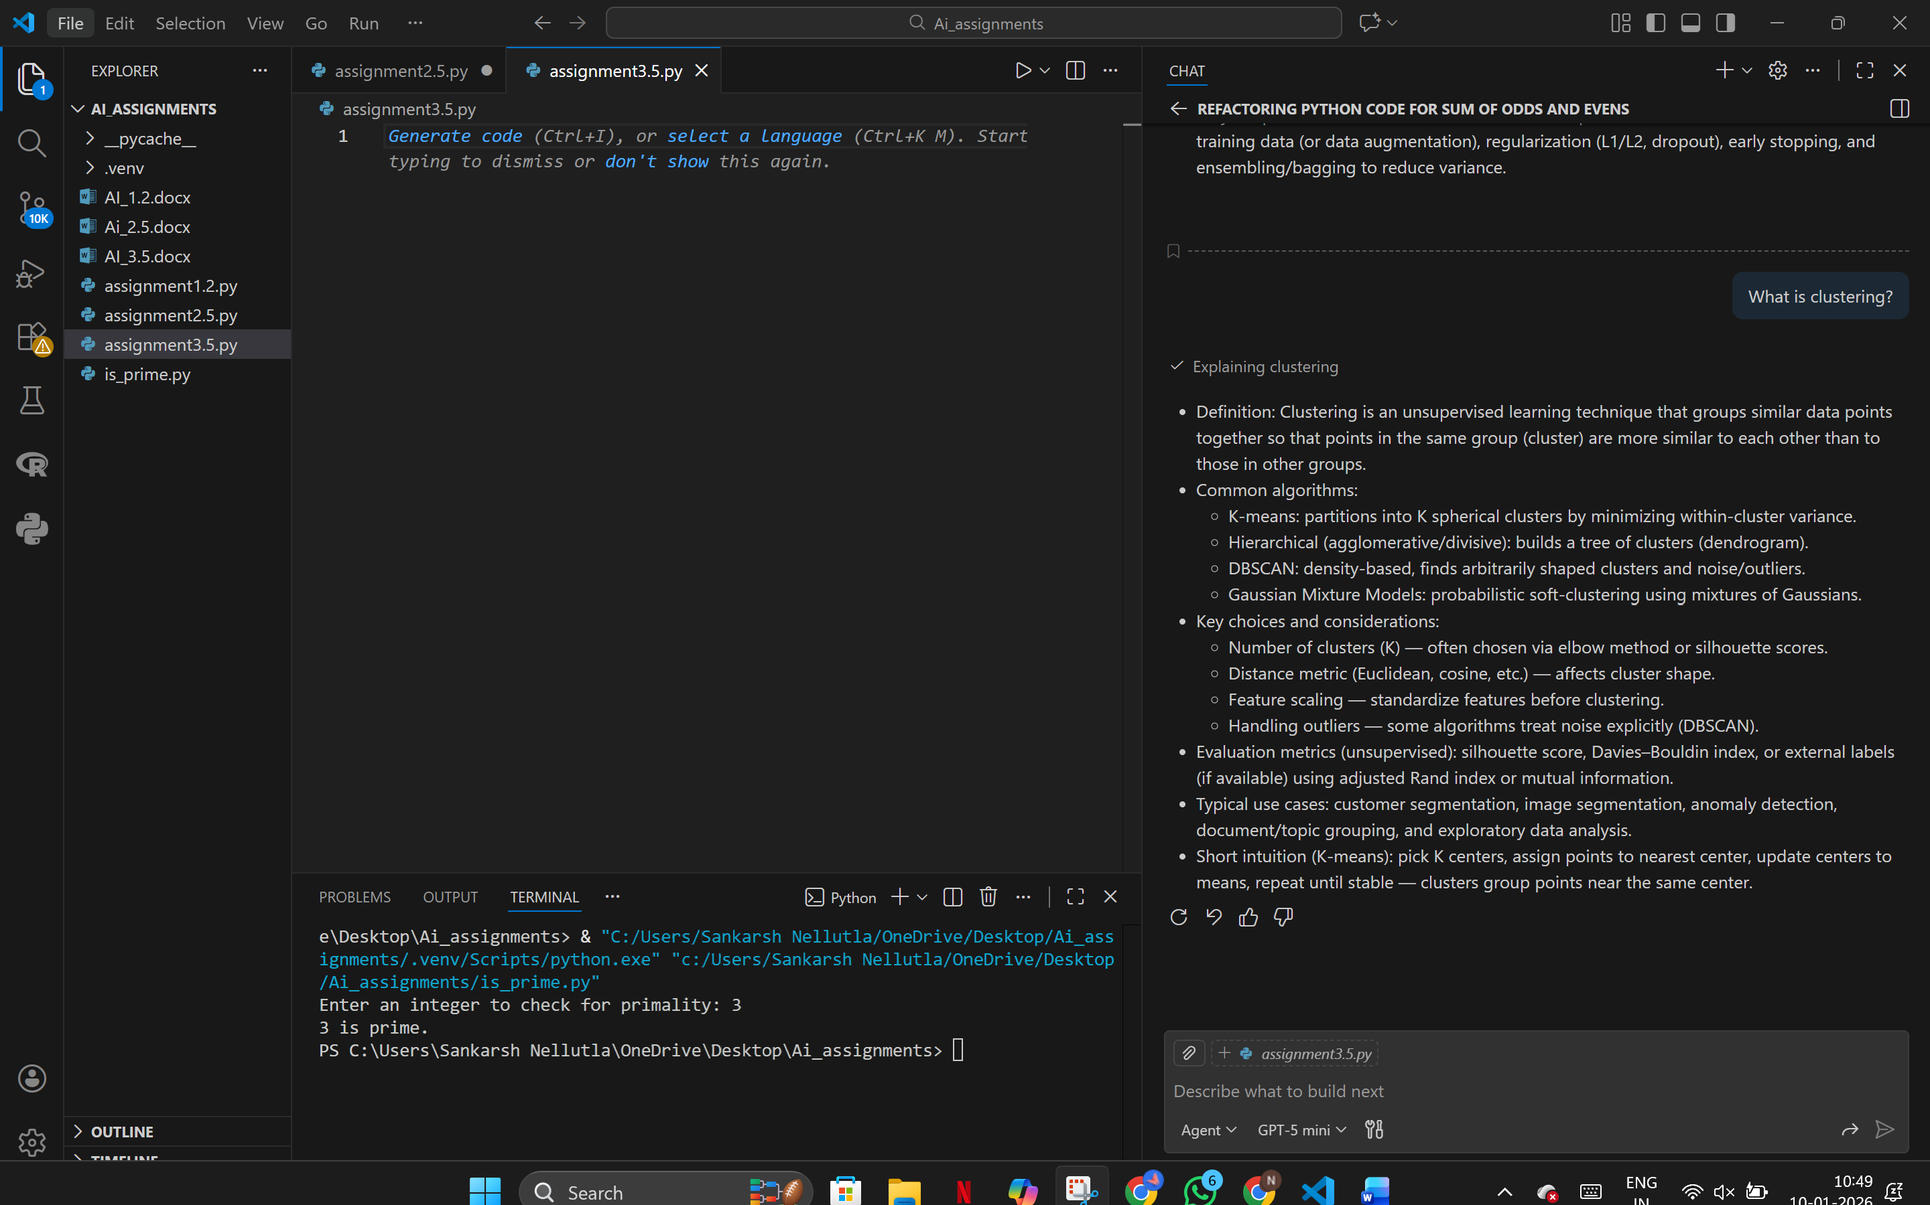

**Prompt Refinement**

Define supervised learning.

Explain its working.

List types.

Give one real-world example.

Mention one limitation.

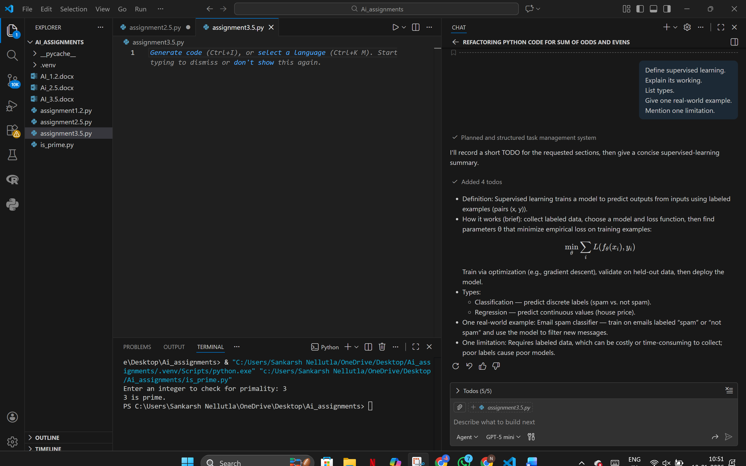

**Evaluation Table**

| **Metric** | **Baseline** | **Refined** |
| --- | --- | --- |
| **Completeness** | **2** | **5** |
| **Accuracy** | **4** | **5** |
| **Relevance** | **3** | **5** |
| **Clarity** | **2** | **5** |

**Reflection**

**Context management greatly improved conceptual clarity. Refined prompts helped Copilot generate structured, domain-accurate explanations.**

**Task 4: Database and SQL Queries**

**Explain SQL JOIN**

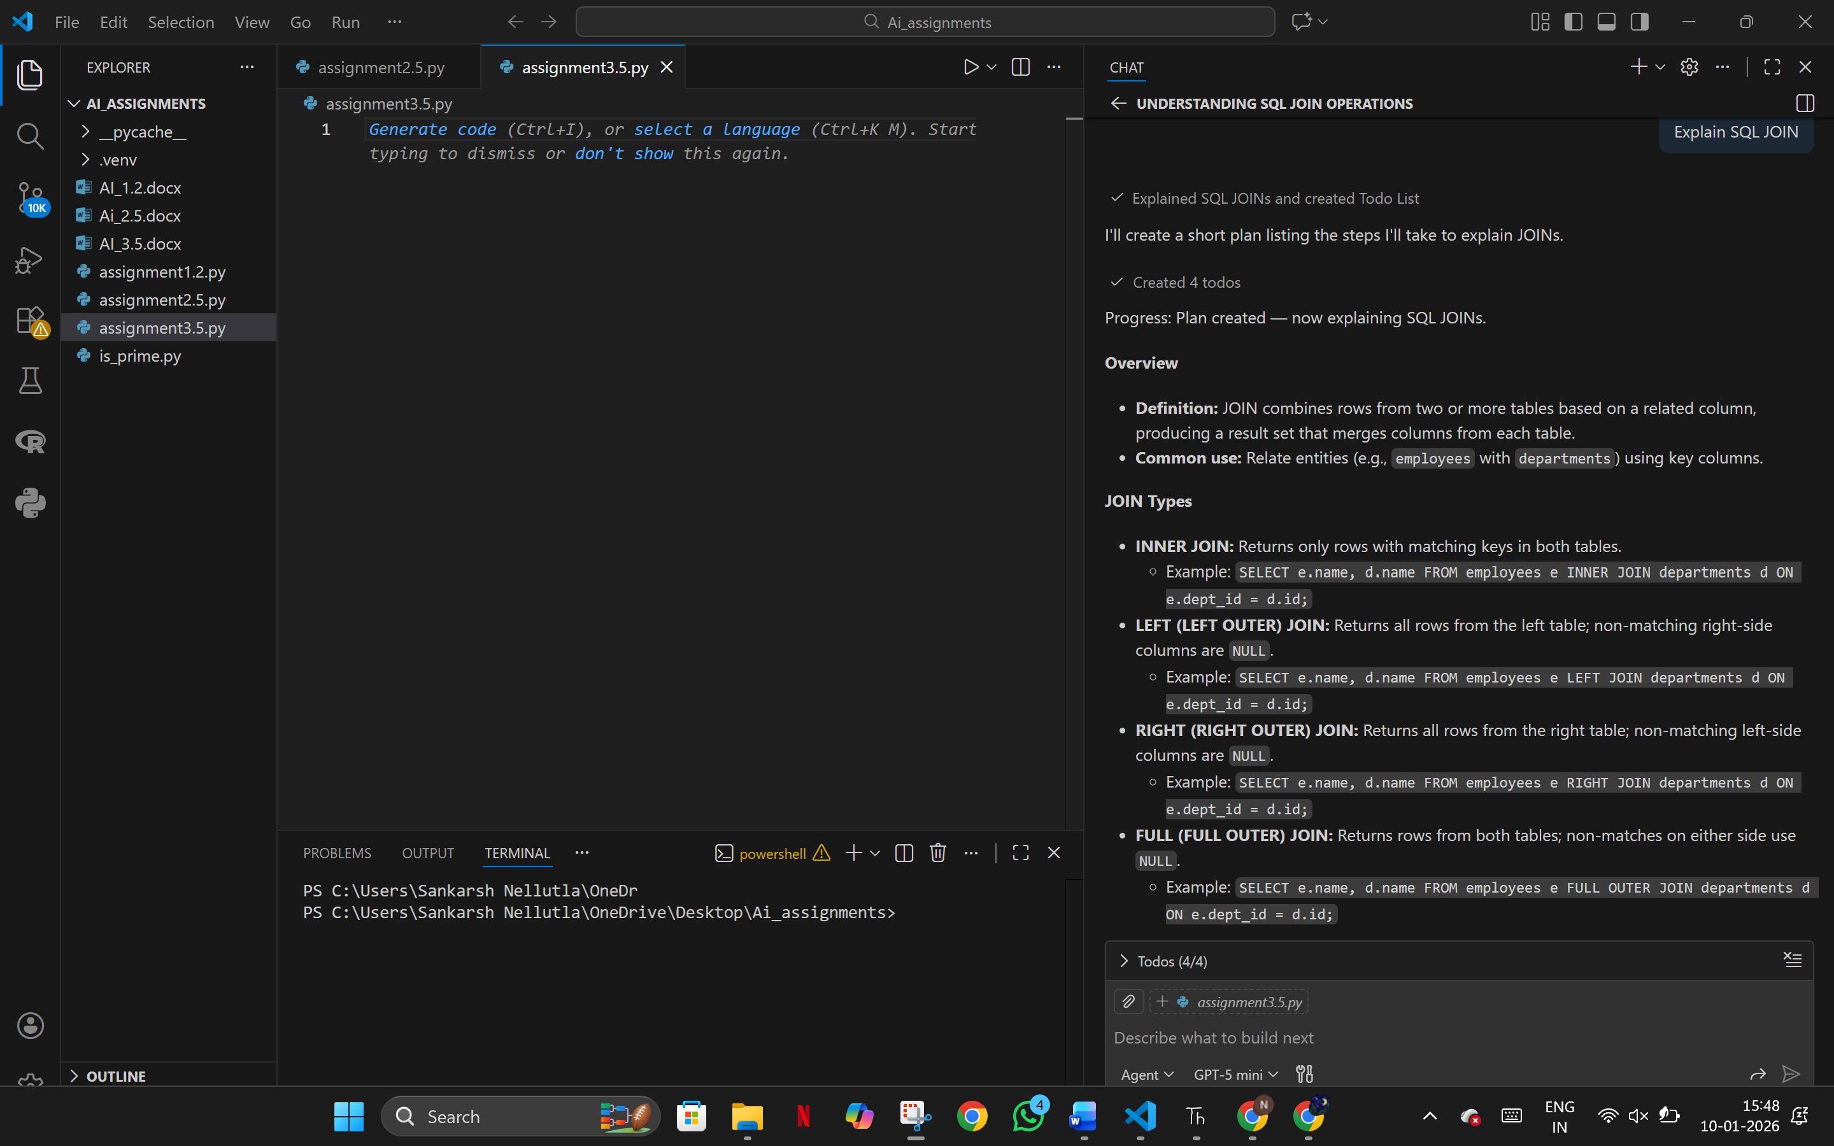

**What is a primary key?**

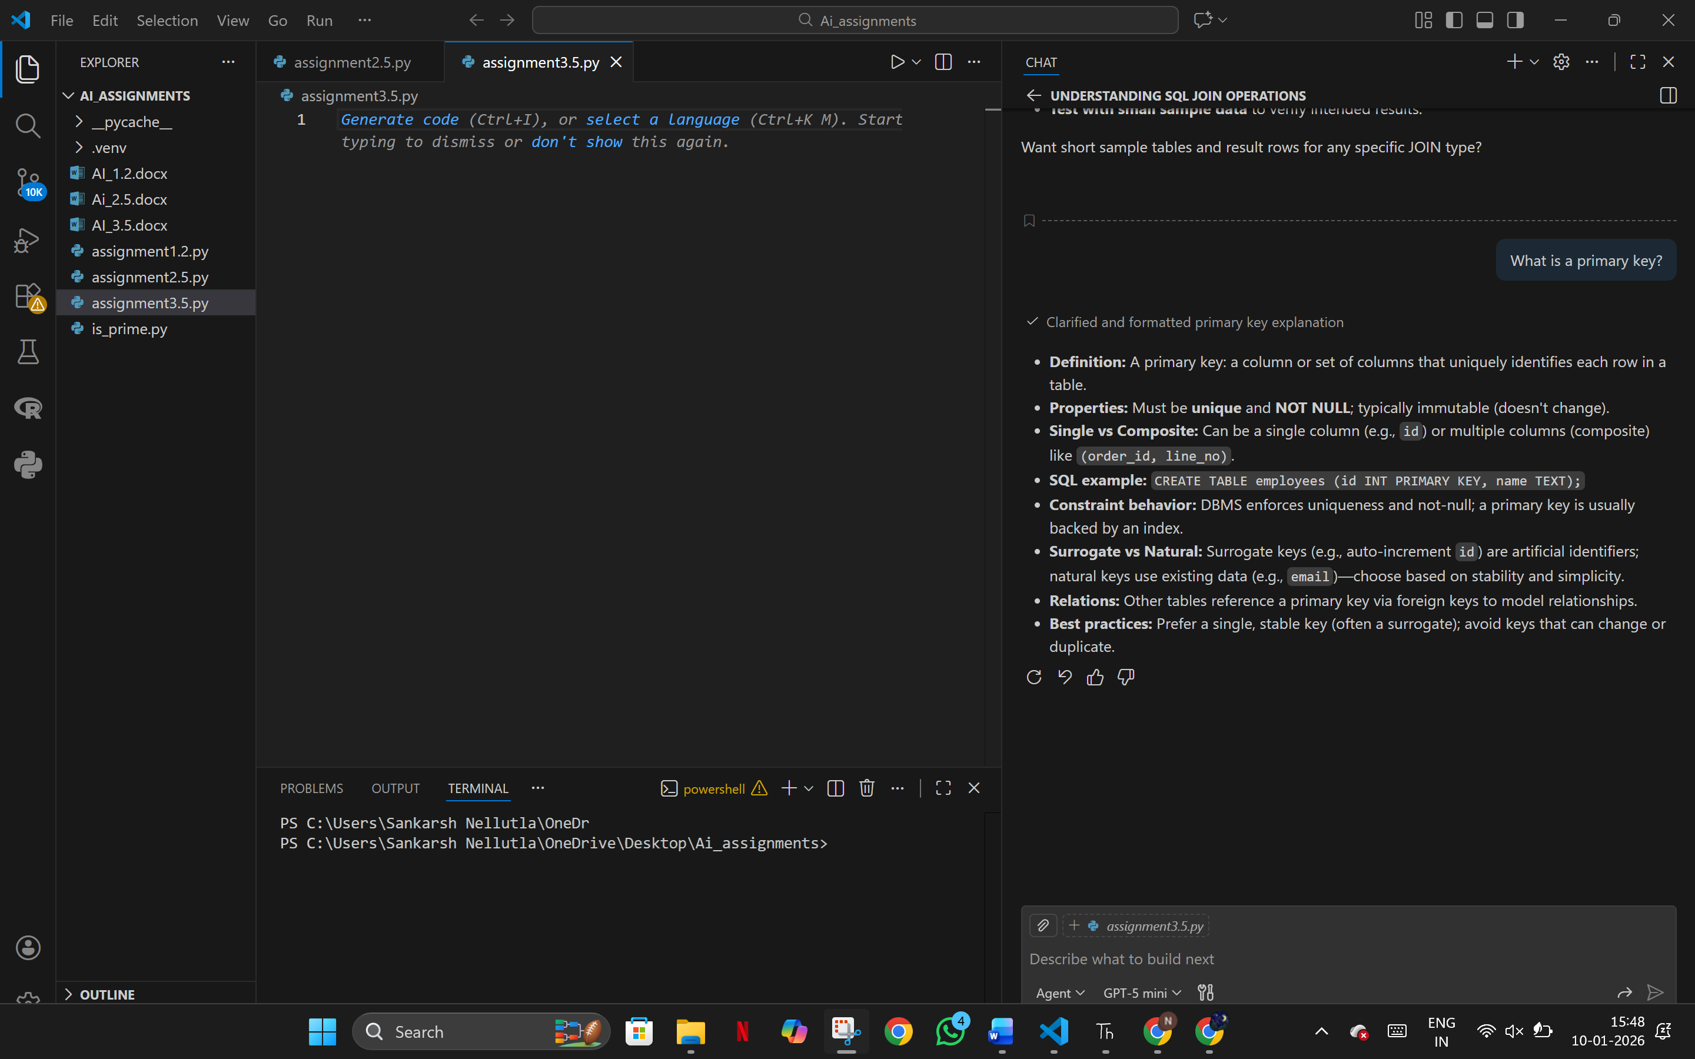

**Difference between DELETE and TRUNCATE**

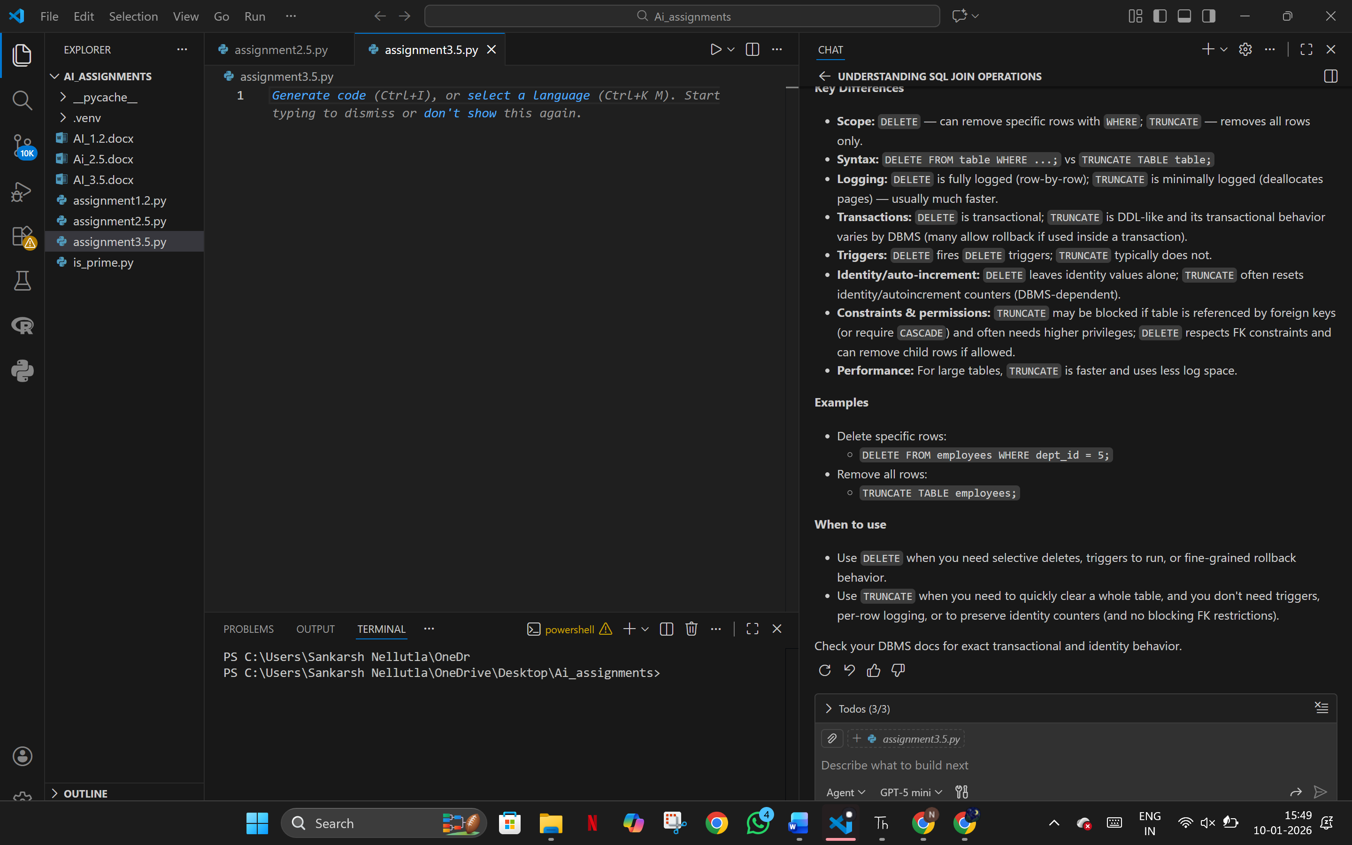

**Where clause in SQL**

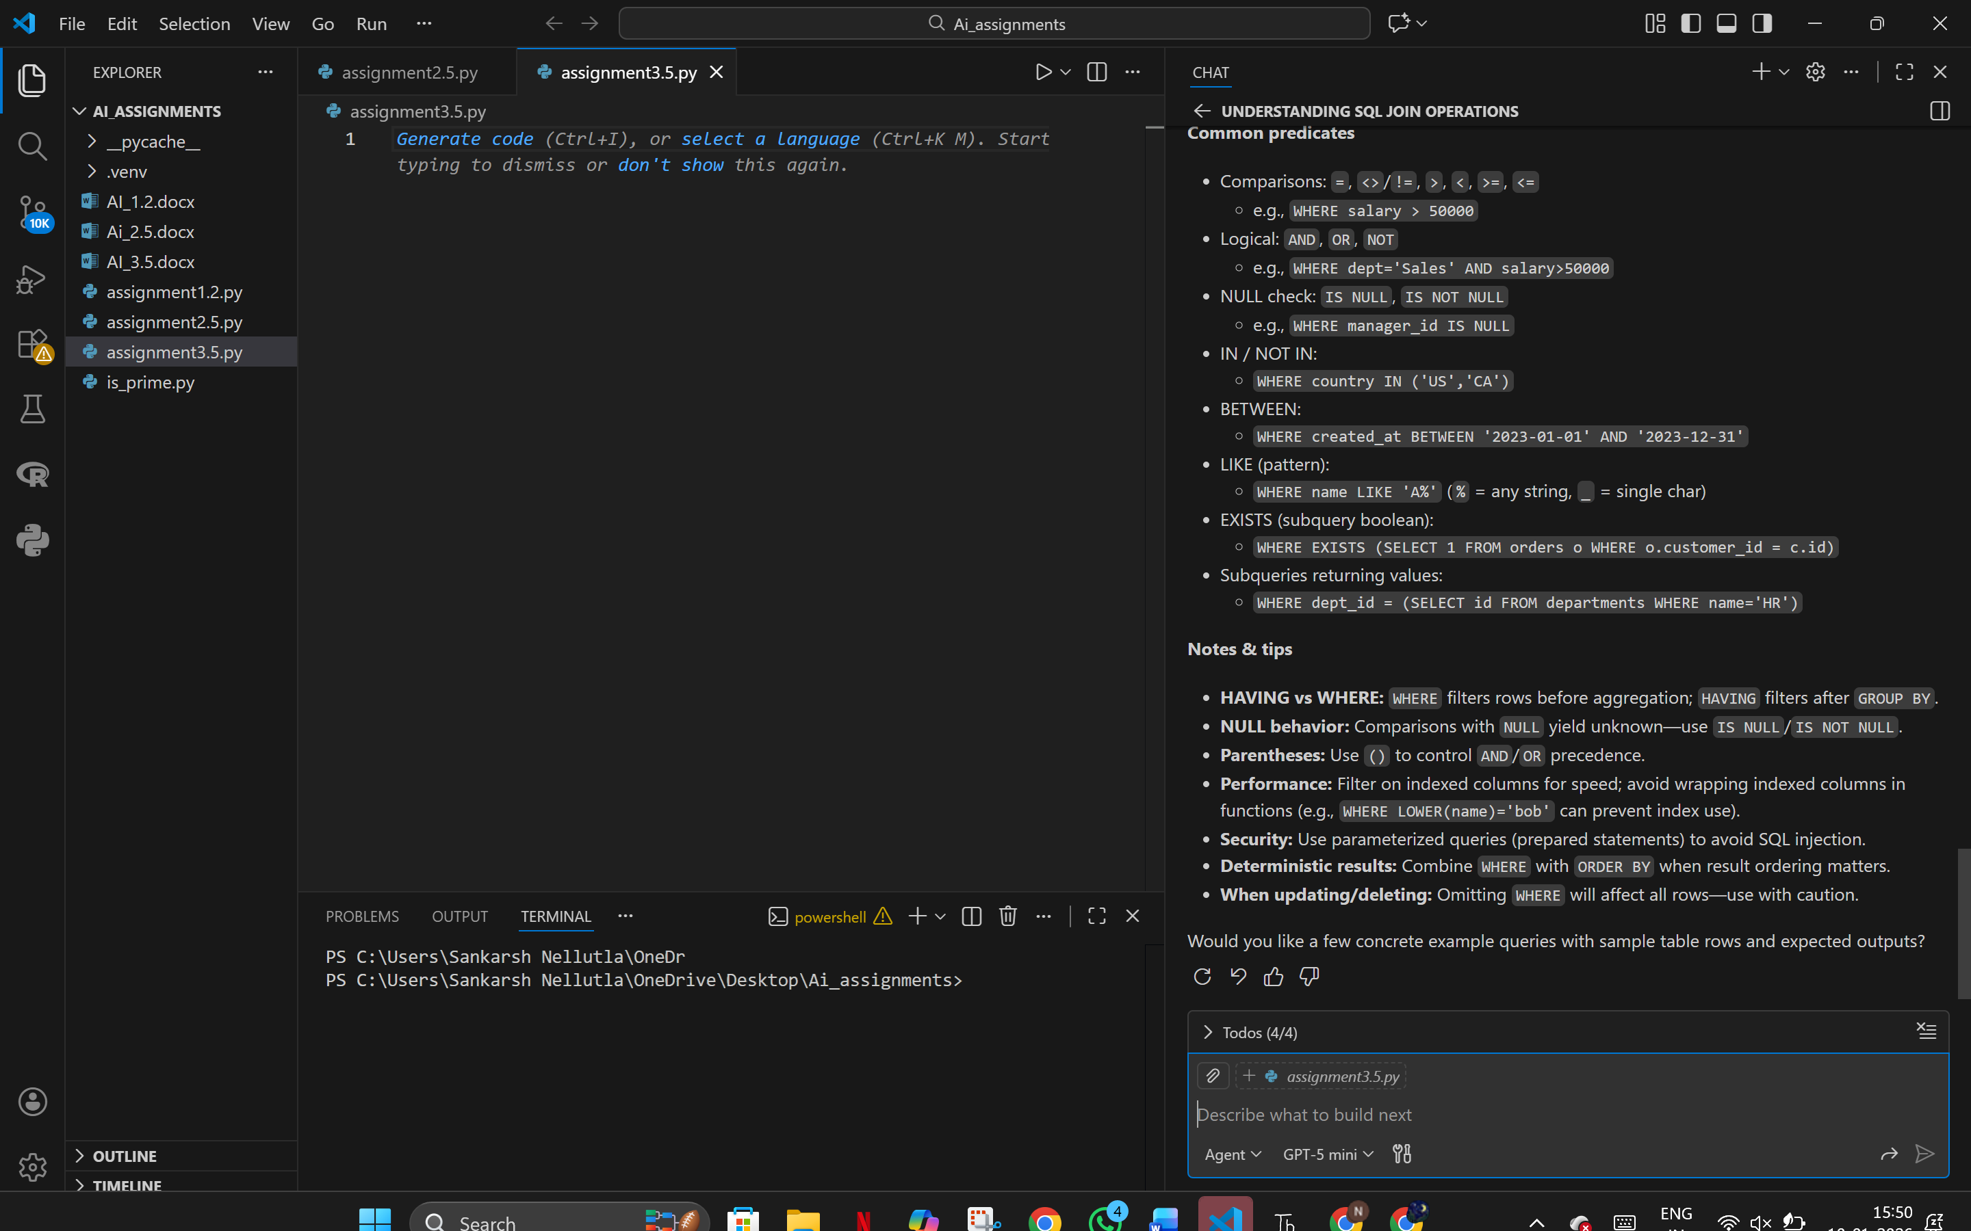

**How does indexing work?**

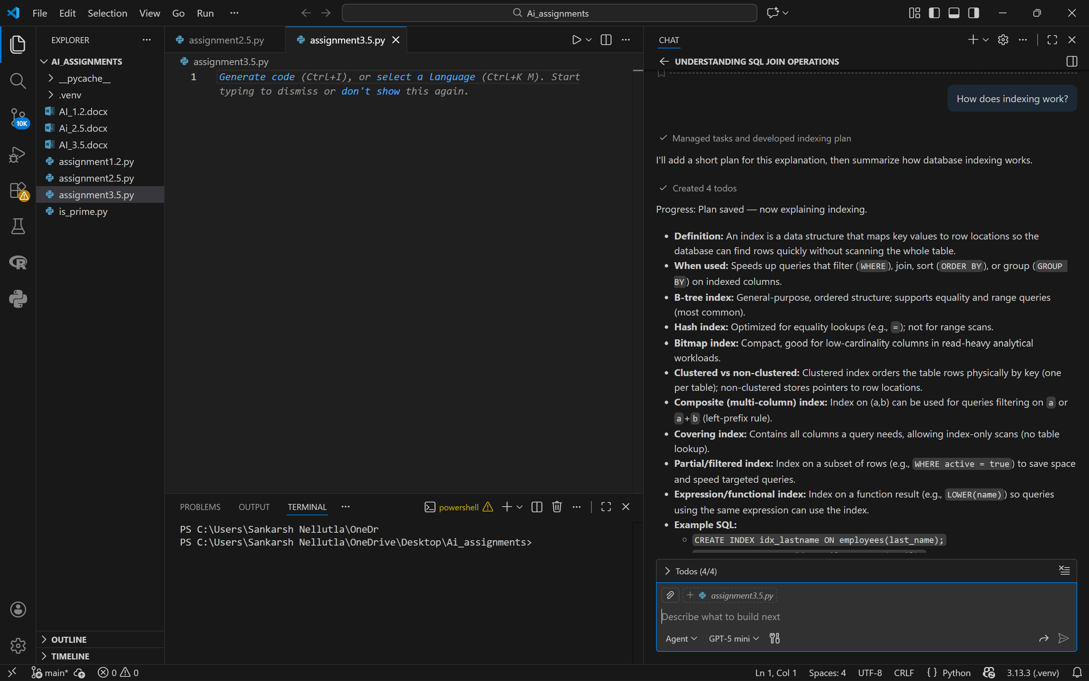

**Prompt Refinement**

Explain SQL JOIN types.

Include:

1) Definition

2) Syntax

3) Example

4) Use case

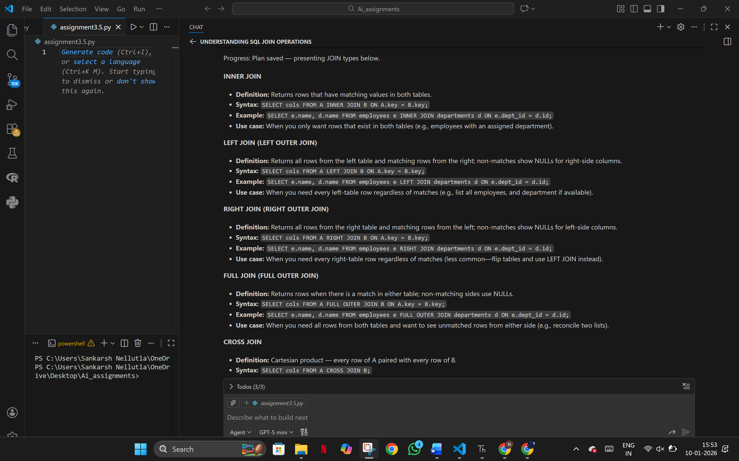

**Evaluation Summary**

| **Metric** | **Baseline** | **Refined** |
| --- | --- | --- |
| **Completeness** | **2** | **5** |
| **Accuracy** | **4** | **5** |
| **Relevance** | **3** | **5** |
| **Clarity** | **3** | **5** |

**Reflection**

Refined prompts reduced ambiguity and improved technical accuracy, especially for SQL syntax and examples**.**

**Task 5: General Aptitude and Logical Reasoning**

Scenario

You support competitive exam aspirants.

**What is probability?**

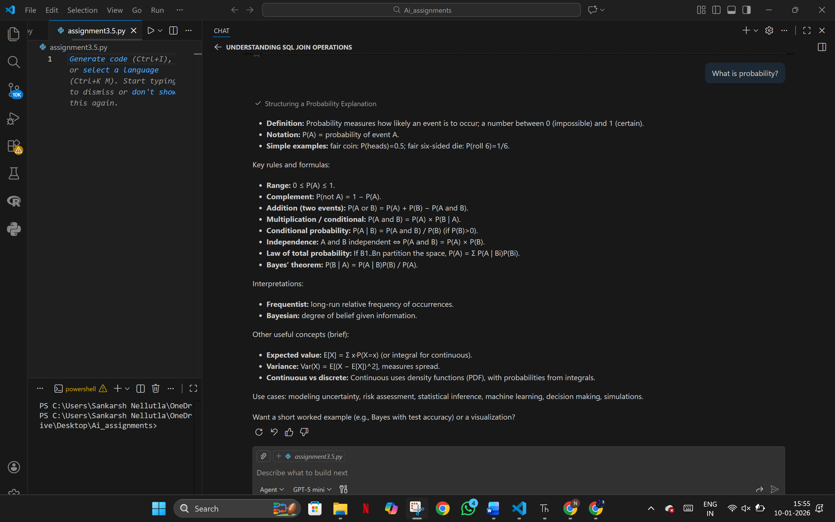

**Explain ratio**

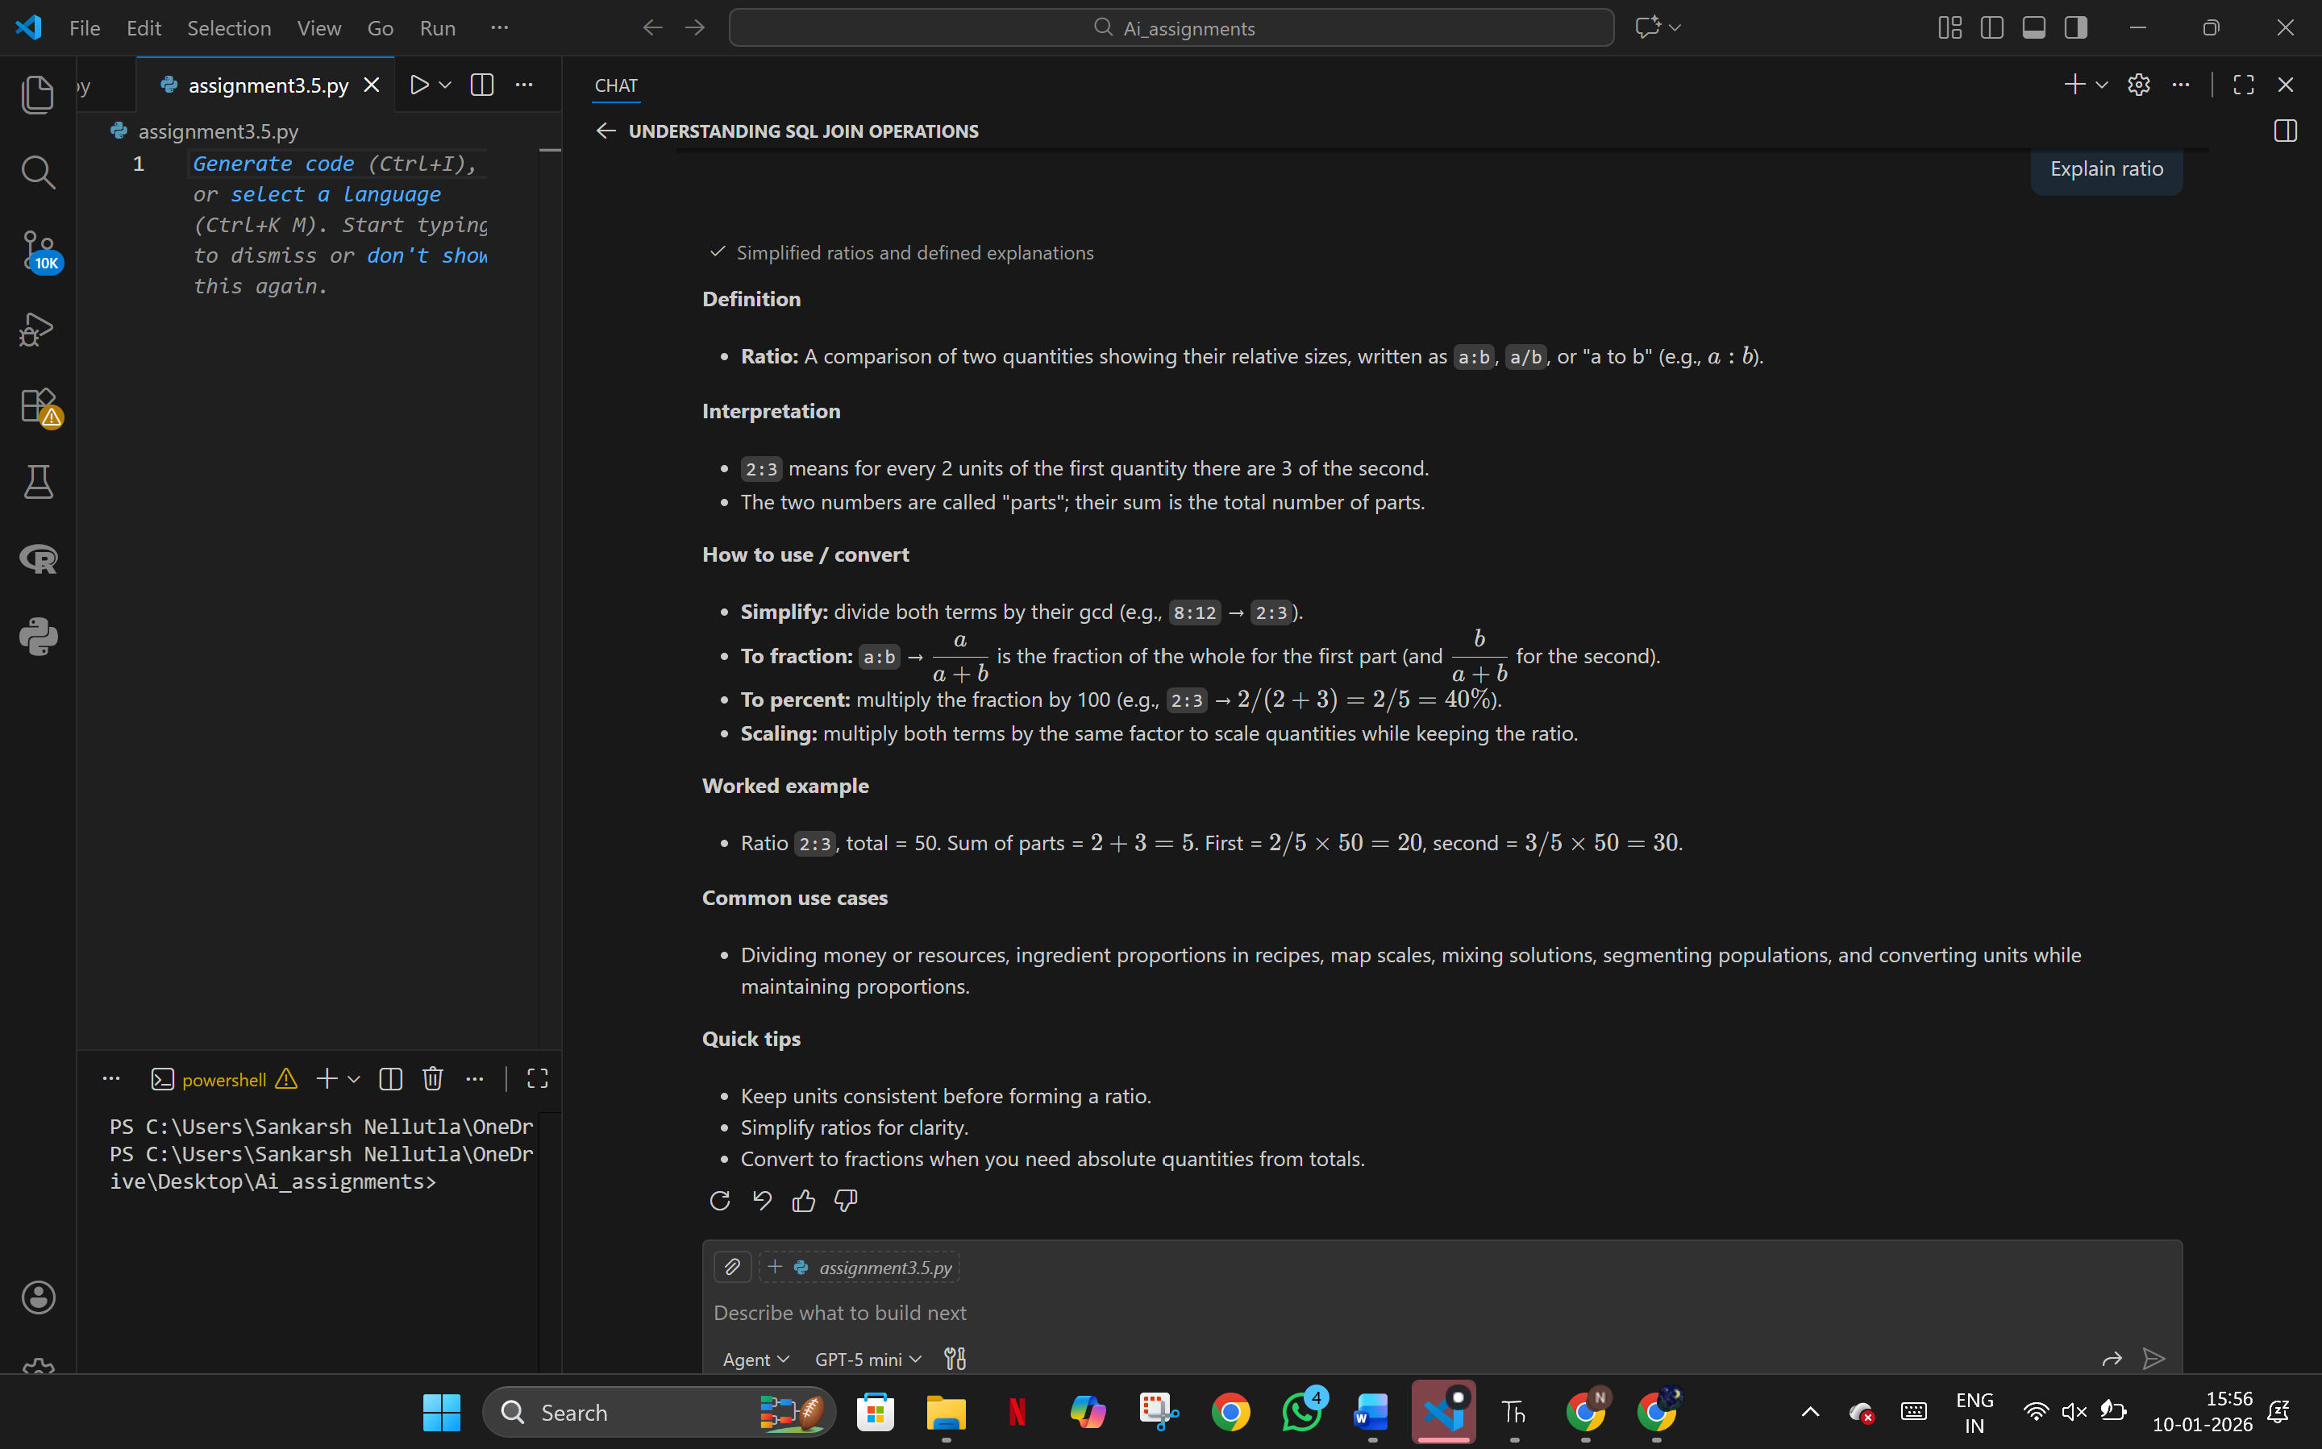

Difference between permutation and combination

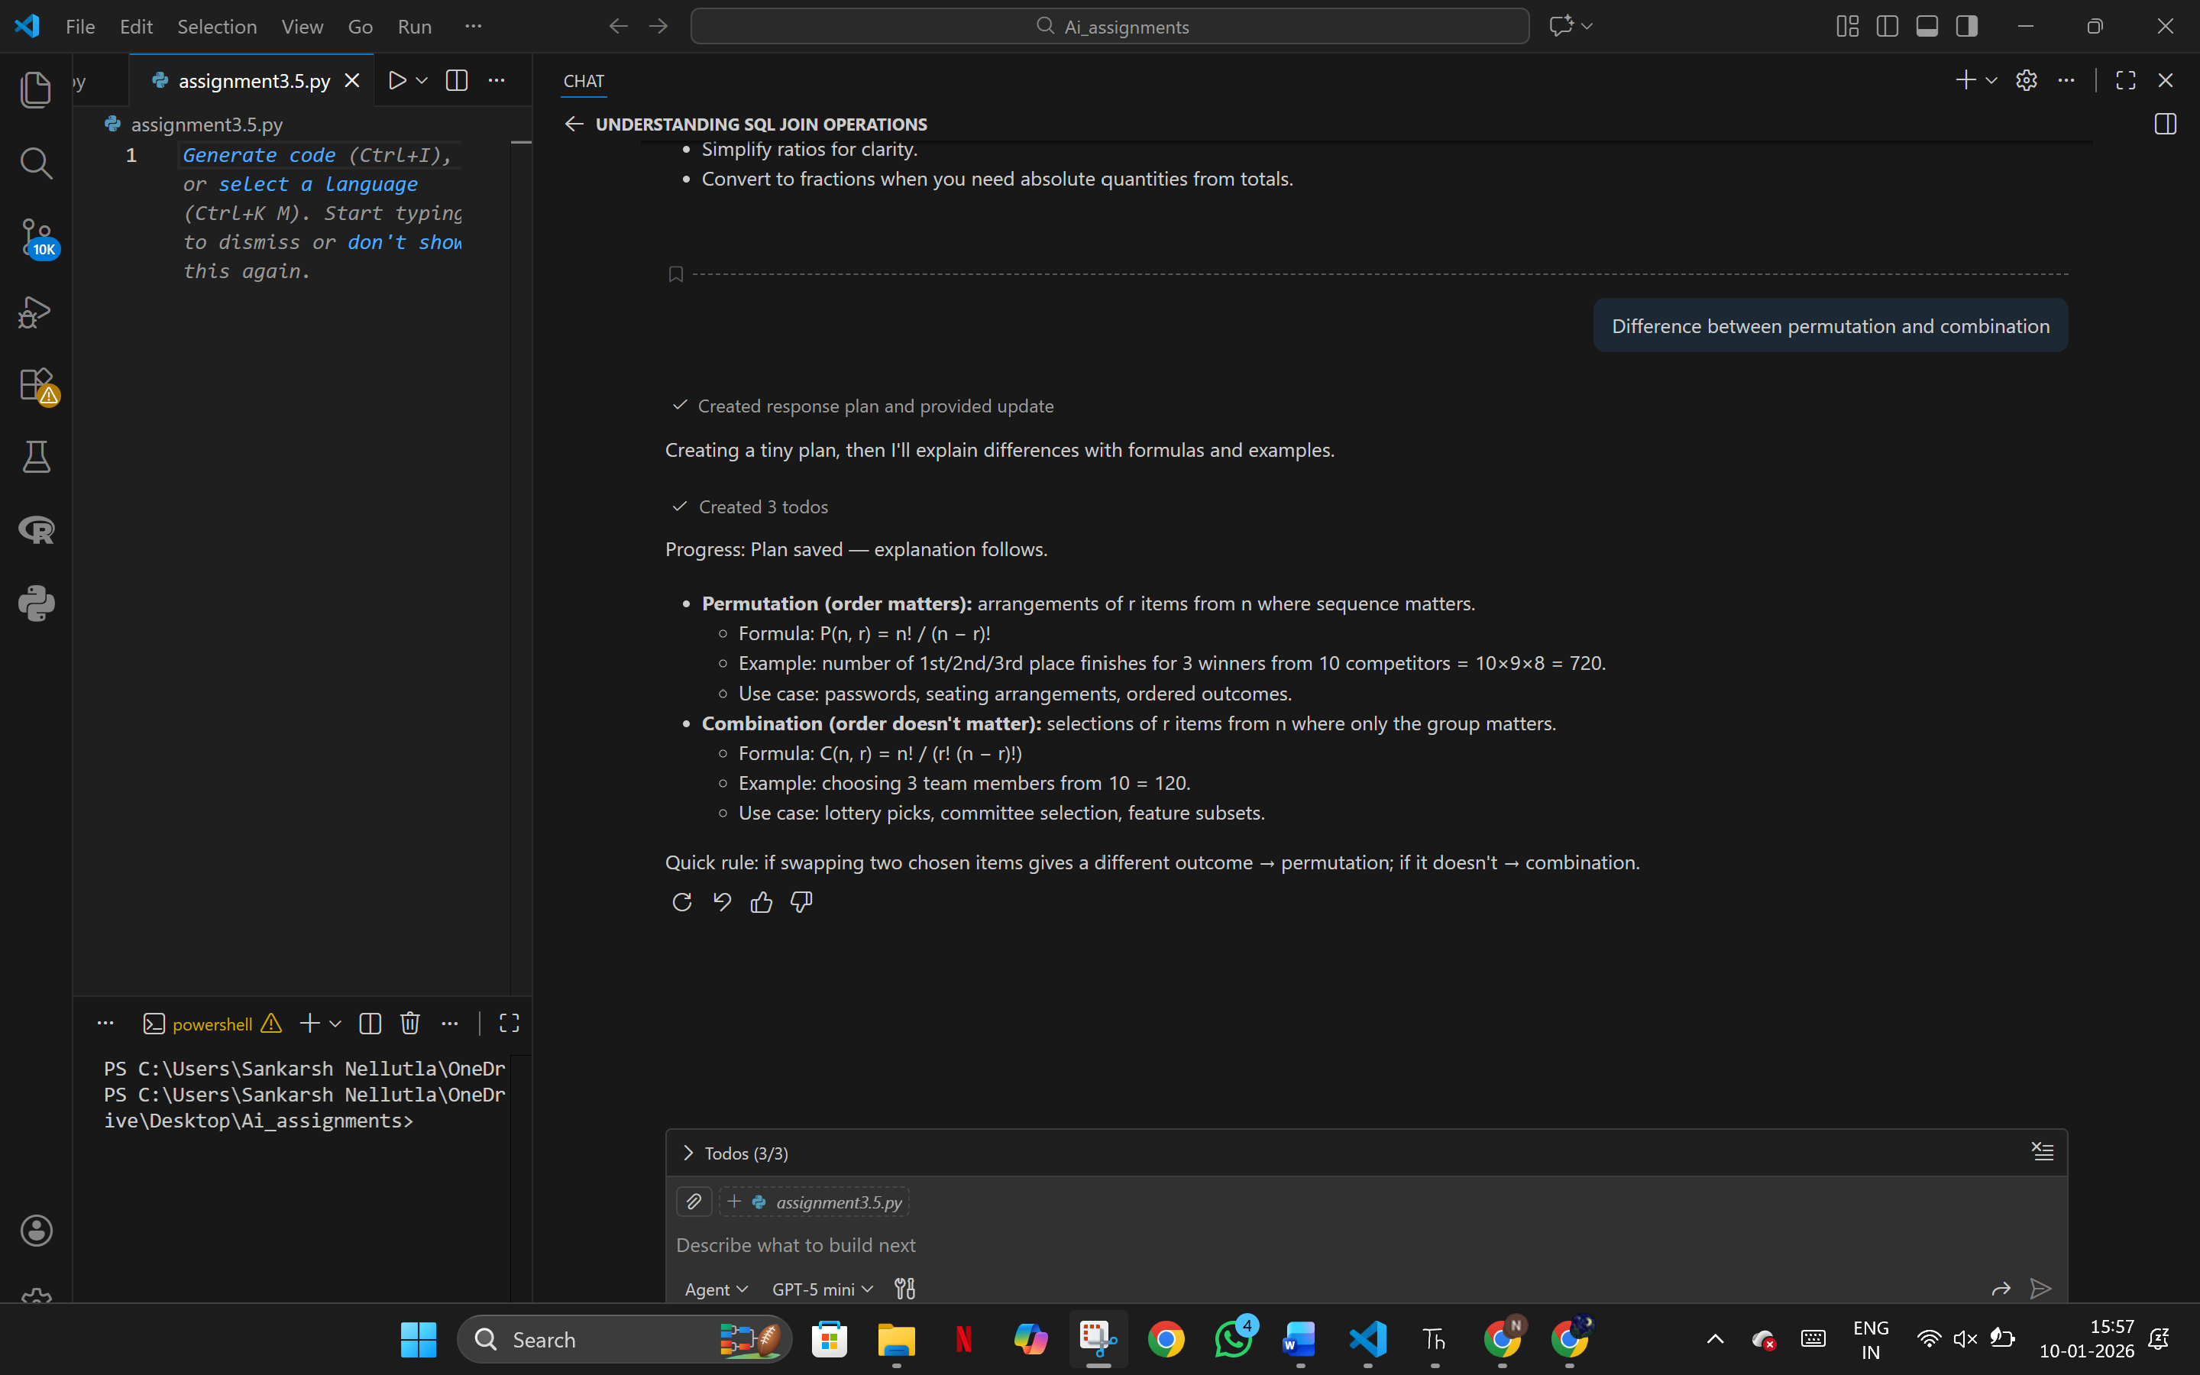

**Where is profit-loss used?**

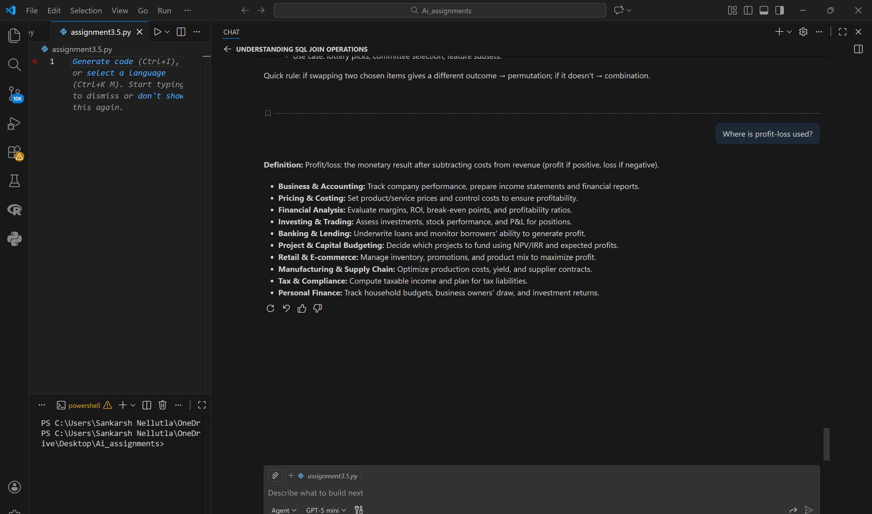

**How to solve time and work problems?**

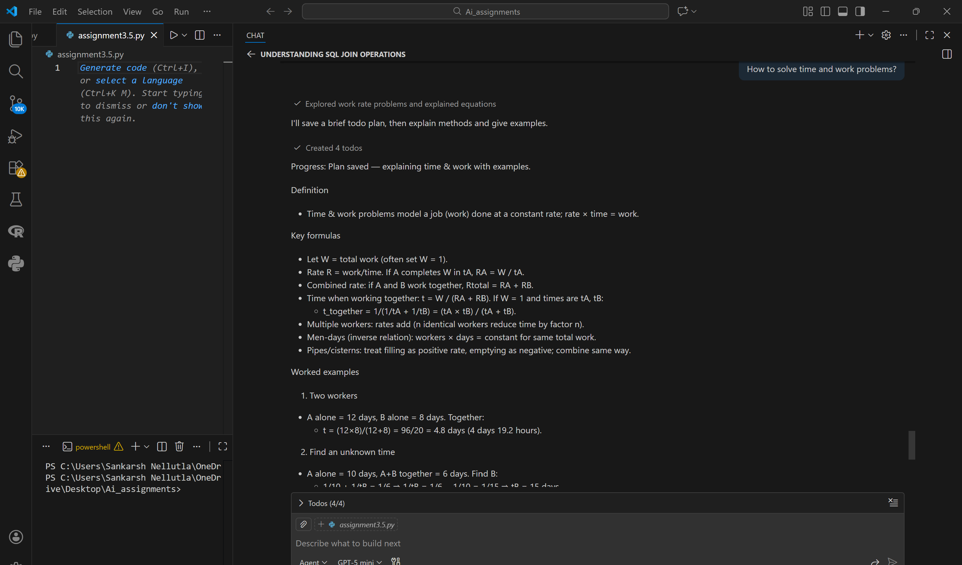

**Prompt Refinement**

Define probability.

Give formula.

Solve one simple numerical example.

List common mistakes.

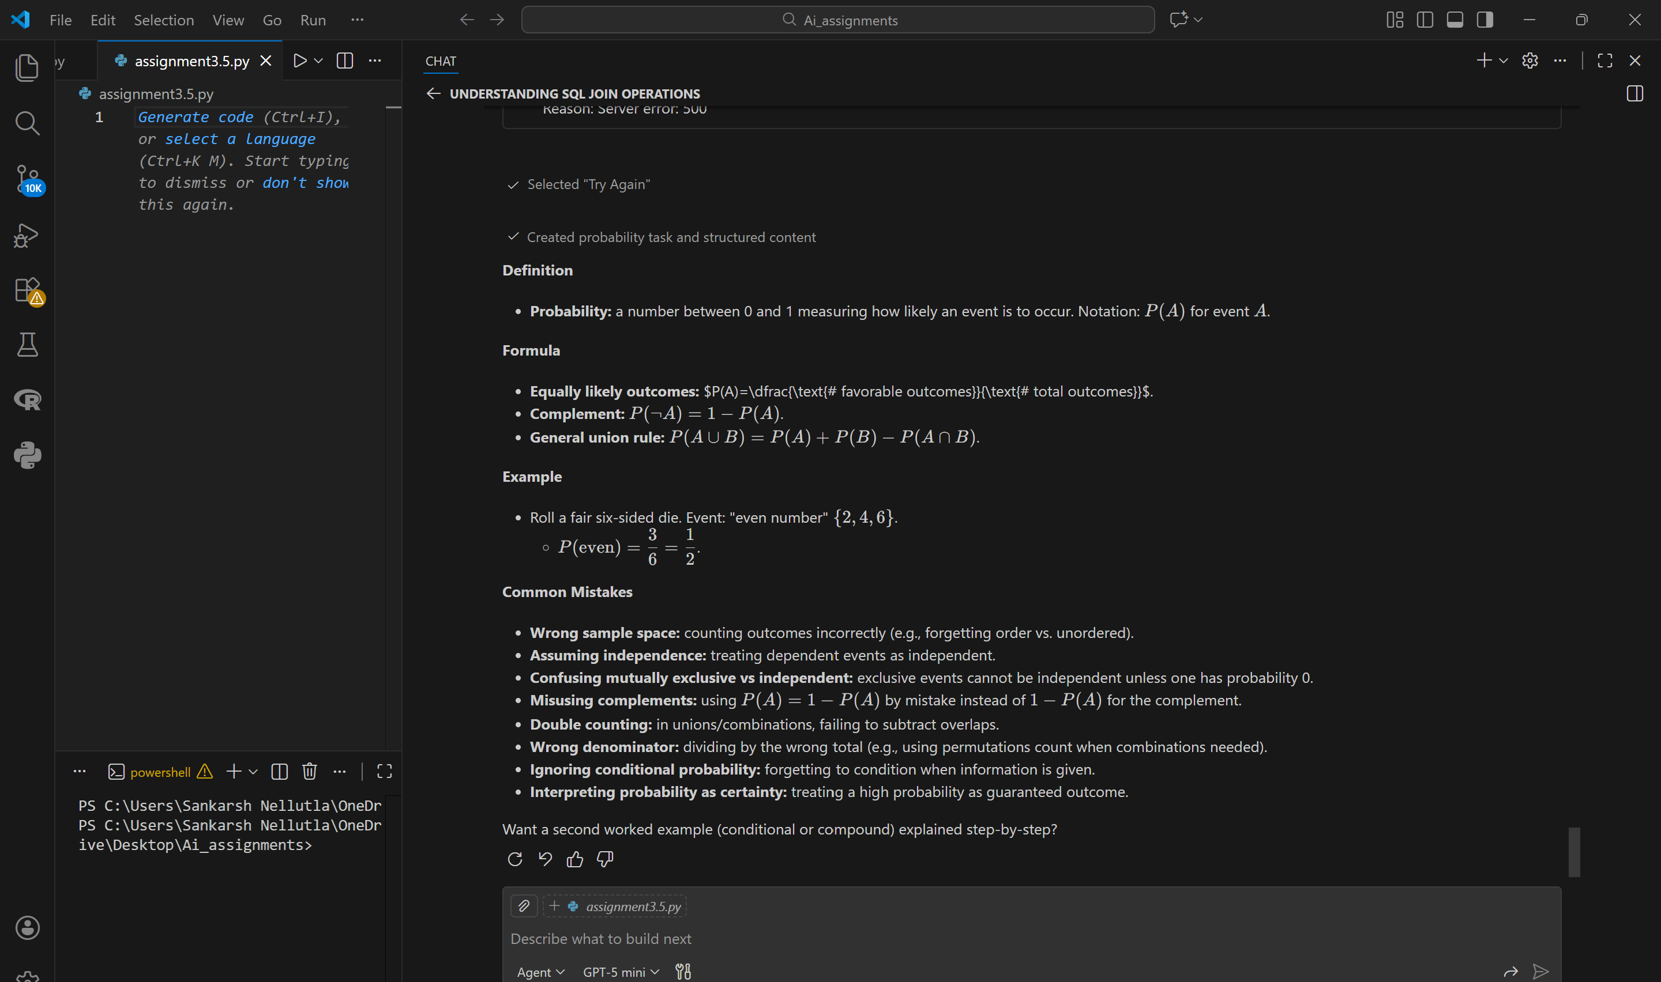

**Evaluation Table**

| **Metric** | **Baseline** | **Refined** |
| --- | --- | --- |
| **Completeness** | **2** | **5** |
| **Accuracy** | **4** | **5** |
| **Relevance** | **3** | **5** |
| **Clarity** | **2** | **5** |

**4. Reflection**

**Structured prompts improved step-by-step reasoning and made solutions easier to understand for learners.**

**Overall Conclusion**

**This lab demonstrates that prompt engineering directly impacts response quality.  
Using GitHub Copilot with clear context, subtasks, and explicit instructions significantly improves completeness, clarity, and correctness across domains.**